San Luis Obispo
Local Agency Formation Commission

Proposal Application

If you have any questions, please contact us at:

1042 Pacific Street, Suite A, San Luis Obispo, CA 93401

Tel: 805-781-5795 | Fax: 805-788-2072

Email: rfitzroy@slo.lafco.ca.gov | www.slo.lafco.ca.gov

Updated: September 2022

TABLE OF CONTENTS

- REQUIREMENTS FOR LAFCO APPLICATION - CHECKLIST 2
- STANDARDS FOR MAPS AND LEGAL DESCRIPTIONS 5
- PUBLIC HEARING NOTICE MAILING LIST REQUIREMENTS 9
- FEES AND COST-ACCOUNTING AGREEMENTS 11
FORMS AND SAMPLES

Form A - Proposal Application 18

Form B - Notice of Intention to Circulate Petition 25

Form C - Petition for Proposal 27

Sample Resolution of Application 36

Sample Property Owner Consent Letter 37

Sample Statement of Boundary Change Form 38

If you have any questions, please contact us at 805-781-5795 or visit our website at: www.slo.lafco.ca.gov or
email one of us at the following addresses: rfitzroy@slo.lafco.ca.gov imarquez@slo.lafco.ca.gov
mbing@slo.lafco.ca.gov

I. REQUIREMENTS FOR LAFCO APPLICATIONS

Instructions:

- Please use this checklist to prepare the proposal application
- We accept both digital and hard copy submittals
- If you have any questions, please contact us at 805-781-5795 or visit our website at: www.slo.lafco.ca.gov or email one of us at
at the following addresses:

rfitzroy@slo.lafco.ca.gov
imarquez@slo.lafco.ca.gov
mbing@slo.lafco.ca.gov

I. REQUIREMENTS FOR LAFCO APPLICATIONS - CHECKLIST

Application Checklist

A formal application filed with the LAFCO Executive Officer must include the following:

    - A PETITION OR A RESOLUTION

An application may be filed by either petition of a proponent (an individual or group) or by a resolution of a legislative body (a city, county, or special district, etc.). A sample resolution of the application can be found in Sample D of this Application Packet. A Notice of Intention to Circulate a Petition can be found in Form B and must be submitted to the Executive Officer. A blank petition is included in Form C for your use. Examples of petitions and resolutions are available for review at the LAFCO Office.

    - MAPS AND LEGAL DESCRIPTIONS

Applicants must initially submit three full copies and one reproducible 8 ½” x 11” copy of maps and legal descriptions of the exterior boundaries of the territory proposed. Maps and legal descriptions must be prepared and certified by a civil engineer or licensed land surveyor. Please include all background material such as deeds or tract maps. After the maps and legal descriptions have been reviewed and certified by the San Luis Obispo County Surveyor, eight full size maps and one copy-ready 8 ½” x 11” map must be submitted. Information on map and legal description standards can be found in Section II of this application packet.

    - PROPOSAL APPLICATION - ENVIRONMENTAL INFORMATION (FORM A)

The Proposal Application form includes a Justification of Proposal Questionnaire that must be completed. This questionnaire is included in this packet as Form A for your use.

Any environmental determination (CEQA decision) regarding the proposal should be submitted. If LAFCO is to perform the CEQA review an environmental assessment of the site and other environmental studies may be required.

    - PUBLIC HEARING NOTICE MAILING LIST REQUIREMENTS

The Public Hearing Notice Mailing List Requirements are included for your use in Section III. It must be signed and include a list of associated assessor

parcel map numbers (APNs) and County Assessor maps detailing property owners within 300 feet of the exterior boundaries of the project site. Two sets of mailing labels for the property owners within 300 feet of the exterior boundaries must be included.

A sample letter of consent from each affected property owner is required if the application is to be processed without public notice or hearing. A consent letter is attached for your use in Sample E.

For area with 12 or more people, a mailing list of registered voters must be provided. The list can be obtained from the County Clerk-Recorder.

    - FEES AND COSTS - ACCOUNTING AGREEMENTS

A LAFCO cost-accounting agreement and a County Planning and Building Department cost-accounting agreement must be completed and submitted along with applicable fees. Both of these agreements are included in Section IV of this packet along with a LAFCO fee schedule and fee calculation worksheet.

APPLICATIONS BY CITIES AND DISTRICTS MUST ALSO INCLUDE THE FOLLOWING:

    - A PLAN FOR PROVIDING SERVICES WHICH INCLUDES:

      - Enumeration and description of services to be extended to the affected territory.

      - The level and range of such services.

      - An indication of when such services can feasibly be extended to the affected territory.

      - An indication of any improvement or upgrading of structures, roads, sewer or water facilities or other conditions the city could impose or require in the affected territory, should it come under city jurisdiction.

      - An indication of how such services will be financed.

      - Any additional information required by the Executive Officer.

    - CITIES ONLY: A COPY OF THE ADOPTED PRE-ZONING ORDINANCE THAT HAS OCCURRED.

      - The CEQA environmental determination (CEQA documentation).

- Relevant General Plan policies.

II. STANDARDS FOR MAPS AND LEGAL DESCRIPTIONS

Instructions:

Maps and legal descriptions must be consistent with these standards.
- Maps and legal descriptions will be reviewed by the County Surveyor for consistency.
- If you have any questions, please contact us at 805-781-5795 or visit our website at: www.slo.lafco.ca.gov or email one of us at
at the following addresses:

rfitzroy@slo.lafco.ca.gov
imarquez@slo.lafco.ca.gov
mbing@slo.lafco.ca.gov

II. STANDARDS FOR MAPS AND LEGAL DESCRIPTIONS

NOTE: The following standards shall be used for all proposals submitted to LAFCO
and for all County Special District Maps

MAP PREPARATION

- The map shall be prepared by a Registered Civil Engineer or a Licensed Land Surveyor.

- Map size shall be a maximum of 24” x 36” and a minimum of 18” x 26” with a minimum ½” border.

- The map shall bear a graphic scale and a north arrow.

- Scales of maps are to be as large as possible.

- The original map shall be prepared in ink on linen or regular paper.

- To assure microfilming compatibility, lettering should be as large as practical. Minimum letter height for hand lettering shall be .100” with a line of weight of 12 (Radiograph #0). For machine lettering the minimum height shall be .080” with a line weight of 10 (Radiograph #00). The controlling factor is clarity so these minimum sizes should be used only when necessary.

- The point of beginning of the accompanying legal description must be shown on the map.

- The exterior boundaries of any proposed annexation (or other action) must be clearly shown, and the delineation should distinguish between the proposed boundary line and the existing boundary line of the district or municipality.

- The acreage(s) of the affected parcel(s) must be shown on the map.

- All maps shall include a vicinity map showing the general location of the property(ies) and relationship to existing district boundary. This vicinity map may be placed in any corner of the larger map document.

- Dimensions of all roads, easement, rights-of-way, etc., within, adjacent to, or crossing the boundary line of the proposed annexation (or other action) shall be designated on the map sufficient to plot the boundaries and relationship to street rights-of-way and street centerlines. All road names must be shown.

- Where needed to show greater detail, enlargements or blow-ups shall be used. Additional sheets may be necessary.

- The map shall contain a legend explaining the use of various lines and symbols.

- All calls used in the description must be reflected on the map.

- All changes to a map shall be noted in a revision block adjacent to the title block in the lower right-hand corner of the map.

- Maps shall also be submitted on disk in CAD format.

- All parcels within the subject territory that touch the new boundary must be labeled with assessors’ parcel number(s)

LEGAL DESCRIPTION PREPARATION - Descriptions must be definite and certain. Qualitative line calls are necessary along lot lines and road rights-of-way. “To calls” are important for terminus of line points where necessary.

- Because description(s) may use data from several source documents, the call for each line or series of courses shall be given, with the location of the source document.

- The State Board of Equalization requires that the description be geographically plottable. To comply with this requirement, each course will require either a bearing and distance, or will have to be along or to an easily definable existing line (State Highway, Right-of-Way, long existing County Road, ancient subdivision boundary, etc.). In addition, the point of beginning shall be easily definable.

- Sections or fractions of sections may be described in accordance with the “Manual of Instructions for the Survey of Public Lands of the United States”.

- All courses termination at or going along an existing boundary shall have sufficient defining terms to prevent any gaps between the proposed action and the existing boundary.

- The acreage(s) of the parcel(s) will be added at the end of the description(s).

- To assure microfilming compatibility, all characters in the description must be clear and distinct and show good contrast with the background.

Back-up Data: Because of the increasing workload of the County Public Works Department, it is required that back-up data be included with the map and legal description. The back-up data should include all official records and maps used to prepare the map and legal description. For more complex maps calculations should also be included. If insufficient data are included the map and legal descriptions will be returned to the applicant unchecked.

The cooperation of the Applicant during preparation of supporting documents will greatly reduce the time required to process any proposed actions.

SAMPLE

ANNEXATION NO. 1

PARADISE COMMUNITY SERVICES DISTRICT

Beginning at the southwest corner of Lot AL of said subdivision, said point also a point on the westerly boundary line of the Paradise Community Services District; thence southwesterly along the southeasterly line of Cloud Nine Road and the northwesterly line of Lot AM S 19 W 1, 438.5 feet to the southwest corner of Lot AM, thence easterly along the south line of Lots AM, AN and AO East, 2,084 feet to the northwest corner of Lot 8 of the Heavenly Orchards, said point also being on the existing direct boundary, then East, North and West along the existing district boundary to the point of beginning, bearings and distances East 86.55 feet, North 1632.85 feet, and West 1801.92 feet.

Containing 80.5 acres.

Date:

III. PUBLIC HEARING NOTICE MAILING LIST REQUIREMENTS

Instructions:

These requirements may be waived if 100% of the property owners are in favor of the action.

  - If you have any questions, please contact us at 805-781-5795 or visit our website at: www.slo.lafco.ca.gov or email one of us at the following addresses:

rfitzroy@slo.lafco.ca.gov
imarquez@slo.lafco.ca.gov
mbing@slo.lafco.ca.gov

III. PUBLIC HEARING NOTICE MAILING LIST REQUIREMENTS

LAFCO requires that property owners within 300 feet of any parcel(s) being considered for action be notified of any and all public hearings relating to such actions. Information necessary to do this is to be provided by the applicant in the following manner:

Obtain a current copy of the County Assessor map(s) that include your proposal site and all parcels within 300 feet of any part of the proposal site. The exterior property lines of the parcel(s) on which your proposal is located, even if your proposal will occupy only a portion of the parcel(s), must be clearly outlined on the map and another line must be clearly drawn indicating a distance of 300 feet from all exterior property lines you have outlined. Check the scale shown on each map and adjust the adjoining maps if necessary, to include all property within 300 feet. Maps may be purchased from the Assessor’s Office, Room 100, at the County Government Center at a cost of $4.00 per map page.

Please list all Assessor Parcel Numbers (APNs), including book, block, and parcel number, for all parcels located completely or partially within or touching the areas included within the 300-foot boundary.

Include the following with your application submittal:

- The County Assessor map(s) covering the proposal site with the 300-foot area surrounding the site outlined.

- A list of Assessor Parcel Numbers (APNs) from the mapped area.

- Two sets of mailing labels of all property owners within 300 feet of the proposal site.

- This page signed and dated.

I, , hereby certify under the penalty of perjury that the attached information contains all of the APNs of all the property within the area described on the attached application and within a distance of 300 feet from all exterior boundaries of that property.

Signature Date

IV. FEES AND COST-ACCOUNTING AGREEMENTS

LAFCO

Instructions:
Public Works Department

  - Please check with LAFCO staff regarding questions about fees.
  - Cost Accounting Agreements with both the County and LAFCO must be completed and submitted.
  - The Agreement would only be used if the fees were not sufficient to cover processing costs.
  - If you have any questions, please contact us at 805-781-5795 or visit our website at: www.slo.lafco.ca.gov or email one of us at the following addresses:
rfitzroy@slo.lafco.ca.gov
imarquez@slo.lafco.ca.gov
mbing@slo.lafco.ca.gov

IV. FEE SCHEDULE & COST-ACCOUNTING AGREEMENTS
FEE SCHEDULE
(ADOPTED 09/20/01, REVISED 04/27/05, 09/20/07, 03/30/10, 04/30/13, 01/19/17, 09/12/17)

All fees shall be paid prior to the acceptance of an application for processing. All fees should include the appropriate Processing Fee (Minimum $1,500), Environmental Fees and Public Works Department Fee ($720 per application for checking maps and legal descriptions. Please pay this by separate check). Where indicated below, the fees are an initial deposit toward the actual cost of processing a proposal. The applicant shall enter into an agreement to provide for reimbursement to LAFCO for the actual costs of processing an application. A refund shall be issued for any portion of the fee not used for processing. Where fees exceed the required amount indicated below, the applicant shall be notified by the Executive Officer to pay an additional amount equal to the initial deposit. The proposal shall be suspended until such additional funds are deposited with the LAFCO Clerk.

Annexation/Detachment Processing Fees
Acreage
0.1 - 4.99 | $1,500 Deposit Toward Project Cost
5.00 – 9.99 | $2,500 Deposit Toward Project Cost
10.00 – 14.99 | $3,500 Deposit Toward Project Cost
15.00 – 19.99 | $4,500 Deposit Toward Project Cost
20.00 + | $5,000 plus $10.00/acre Deposit Toward  Project Cost
Other Processing Fees
Incorporations, Formations, Other Actions
Formation of a Special District | $5,000 Deposit Toward Project Cost
Incorporation of a City | $15,000 Deposit Toward Project Cost
Dissolution of one or more Districts | $2,500 Deposit Toward Project Cost
Disincorporation of a City | $5,000 Deposit Toward Project Cost
Consolidation of Districts | $3,000 Deposit Toward Project Cost
Merger of Districts | $3,000 Deposit Toward Project Cost
Establishment of Subsidiary Districts | $3,000 Deposit Toward Project Cost
Reorganization of City or District (Two or more of the above changes  of organization, excluding incorporation of a city.) | $7,500 Deposit Toward Project Cost

Sphere of Influence Fees
Sphere of Influence amendment – Result of Proposal –
Acreage
4.99 acres or less | $1,500 Deposit Toward Project Cost
5 - 9.99 acres | $2,500 Deposit Toward Project Cost
10+ acres | $3,500 Deposit Toward Project Cost
Agency Request for Comprehensive SOI Update or Municipal Service Review | $5,000 Deposit Toward Project Cost
Environmental Fees
Initial Study Fee | $500 Deposit Toward Project Cost
Negative Declaration Fee | $1,000 Deposit Toward Project Cost
Responsible Agency | $1,000 Deposit Toward Project Cost
Categorical Exemption | $500 Deposit Toward Project Cost
EIR Appeal Fee | $1,000 Deposit Toward Project Cost
EIR required and LAFCO is Lead Agency | Minimum $5,000 deposit to be increased to equal 25% of the cost of the report
Other Fees
Sphere of Influence Amendment & Annexation/Detachment to a California Water District  - SOI Amendment  - Annexation  - CEQA  Activation of Latent District Powers or Divestiture of Power | $1,000 Deposit Toward Project Cost  $2,000 Deposit Toward Project Cost  $500 Deposit Toward Project Cost  $2,500 Deposit Toward Project Cost
Request for Reconsideration | $1,500 Deposit Toward Project Cost
Fee Waiver Request | $500 Deposit Toward Project Cost
Request for Time Extension | $500 Deposit Toward Project Cost
Study Session Request | $2,500 Deposit Toward Project Cost
Request for Fiscal Analysis or Other Studies | $2,500 Deposit Toward Project Cost
Outside User Agreement | $2,500 Deposit Toward Project Cost
Pre-application Review | Limited to three (3) hours of staff time,  then actual cost
Petition Verification Fee | filing fee of $10 + $1.00 per signature
Processing request for the State Controller's review of an incorporation fiscal analysis | $1,500
Annual Agenda Mailing List Fee | $25
Executive Officer's Report (Monthly mailings for 12 months) | $100
Copying Fee | $.10 per page

State Fees
State Board of Equalization, State Controller's Office and the Department of Fish and Game Fees in accordance with their fee schedules. These fees are collected after proposal approval.

Other Charges
In additional to the fees specified herein, the Executive Officer may charge an applicant/appellant for the actual costs that are incurred as a result of processing a proposal that are not covered in the Commission's fee schedule. An applicant/appellant may appeal the decision of the Executive Officer in writing. Such appeal will be presented to the Commission at its next meeting.

Refunds for withdrawn proposals shall be based on an estimate by the Executive Officer of the total costs incurred in processing the proposal up to the date of the withdrawal request.

Fee Waiver
The Commission, upon a finding that such action would be in the public’s best interest and/or is necessary for health and safety reasons, may waive fees partially or in total. Requests for fee waiver must be submitted in writing to the Commission. Fees may be waived by the Executive Officer for proposals filed in response to Commission conditions.

Public Works Department Fee
$720 per application for checking maps and legal descriptions pursuant to County Fee Schedule.

Clerk-Recorder Department Fee
$50 for processing and filing a Notice of Determination as set forth in CEQA Guidelines.

LAFCO Charge-out Rates:

Executive Officer | $110/hour
Analyst | $85/hour
Commission Clerk | $50/hour
Legal Counsel | $150/hour

FEE SCHEDULE WORKSHEET

- Processing Fee (depends upon proposal type): $

Annexation fees are based upon total acreage. Other types of proposals also include a processing fee. Reorganizations (two or more changes of organization) have a separate fee.

Sphere of Influence Fee: $

SOI fees are also based upon acreage and represent an initial deposit toward the proposal’s processing cost.

- Environmental Fees: $

Environmental Determination fees are required for compliance with the California Environmental Quality Act (CEQA).

- Other Fees: $

Total LAFCO Fees Due with Application Filing: $ Checks should be made payable to LAFCO.

- Public Works Department Fee $720.00
$720.00 per application for checking maps and legal descriptions. A separate check made out to the County is required.

State Board of Equalization (BOE) & County Clerk-Recorder Fees: $

The BOE fees are paid after LAFCO approval has been granted. A separate check made out to the State Board of Equalization is required.

If you need help in determining your fees, please contact LAFCO staff for assistance at (805) 781-5795.

COST ACCOUNTING AGREEMENT

Applicant:

Mailing Address:

Telephone:

Fax:

E-mail Address:

The cost of processing an application may exceed the initial deposit required. In order to recover any additional costs associated with processing your application, the Local Agency Formation Commission, LAFCO, has found it necessary to implement a provision of the Fee Schedule that provides full cost recovery for processing an application.

I, , the landowner and/or responsible Applicant, agree to pay the actual costs pursuant to the Fee Schedule attached hereto, plus copying charges and related expenses incurred in the processing of this application. I also understand that if payment on any billings prior to final action is not paid within thirty (30) days, I agree that processing of my application will be suspended until payment is received.

In order to implement the cost accounting provisions, please sign and date this statement indicating your agreement to the cost accounting procedure agreement. This signed agreement is required for your application to be accepted for processing. Checks may be made payable to LAFCO and delivered or mailed to the LAFCO Office at 1042 Pacific Street, Suite A, San Luis Obispo, CA 93401. If you have questions regarding your application, please contact the LAFCO Office at (805) 781-5795.

Applicant’s Signature Date

Applicant’s Signature Date

Applicant’s Signature Date

FORMS & SAMPLES

Form A: Proposal Application

  - Form B: Notice of Intention to Circulate Petition

  - Form C: Petition for Proposal

  - Sample: Sample Resolution of Application

  - Sample: Property Owner Consent Letter

  - Sample: Statement of Boundary Change Form

Form A
PROPOSAL APPLICATION

Instructions:

  - Please complete the entire form.
(The information is used to evaluate the proposal by LAFCO staff.)

Please attach any documents that may help in that evaluation.
  - If you have any questions, please contact us at 805-781-5795 or visit our website at: www.slo.lafco.ca.gov or email one of us at the following addresses:
rfitzroy@slo.lafco.ca.gov
imarquez@slo.lafco.ca.gov
mbing@slo.lafco.ca.gov

SAN LUIS OBISPO LAFCO
Local Agency Formation Commission
Proposal Application

The California Government Code requires the Commission to review specific factors in its consideration of this proposal. Please complete this form to facilitate our review.

Please provide the names and addresses of the Applicant’s Agent or and/or other persons to whom copies of the Agenda, Executive Officer’s report and any required notice or hearing is to be furnished.

Applicant/Agents
Name | Address | Telephone Number

Interested Parties
Name | Address | Telephone Number

E-mail Addresses

Proposal Type:
- ANNEXATION □ OUTSIDE USER AGREEMENT □ SPECIAL STUDY
- SPHERE OF INFLUENCE □ SPECIAL DISTRICT FORMATION □ INCORPORATION OF CITY
- DISSOLUTION □ MERGERS □ DIVEST/ACTIVATE POWERS
- CONSOLIDATIONS □ REORGANIZATIONS □ DETACHMENT

General Information

Name & Type of Proposal:
(e.g., name, type, jurisdiction)

- This Application was initiated by:

Petition Resolution of Application

- Does the application include 100% written consent of each property owner in the affected territory?

Yes No

- State reason(s) for requesting the proposed action:

- State location of affected territory:

- Is the affected territory inhabited or uninhabited (less than 12 registered voters)?

Inhabited Uninhabited

- Do the boundaries of the district or city overlap or conflict with the boundaries of the proposed annexation?

Yes No

If yes, justify the need for overlapping or conflicting boundaries:

- Do the boundaries of the territory split lines of assessment?

Yes No

- Do the boundaries of the territory proposed create an island or corridor of unincorporated territory or a strip?

Yes No

If yes, justify the necessity for the boundaries as proposed:

- If the proposed boundary follows a street or highway, does it include the entire street or highway?

Yes No

- List the cities or district(s) that will be affected by this proposal:

Land Use Information

- Total acreage: APN #s

- Indicate the zoning. County and City prezoning of the site:

County:

City:

- Describe any special land use concerns found in General Plans:

- Describe the existing land use:

- What is the proposed land use?

- Has the affected territory been prezoned? Yes No

Date: (Please attach ordinance)

If yes, what is the prezoning use and densities (if applicable) permitted?

- Describe the specific development potential of the property:

- Has a Land use Permit, Conditional Use Permit, Tract Map, or Specific Plan or other land use approval been given for the property(ies)?
Yes No
*If yes, please attach a copy of the approval*

Environmental Information
(Please submit any environmental studies that have been completed.)

- Has an environmental determination (Negative Declaration-Environmental Impact Report) been certified by a legislative body?
Yes No
*If yes, please attach a copy*

- Is the site presently zoned for or engaged in agricultural use?
Yes No
If yes, please explain:
_ Prime agricultural land:
Yes No

- Will extension of services requested for this proposal induce growth on affected property? Yes No

On adjacent properties? Yes No

Unincorporated? | Yes | No
Both? | Yes | No
- Will the proposal require public services from any agency or facility that is currently operating at or near capacity, i.e., sewer, water, police, or fire?
Yes No
If yes, please explain:

- Please describe the environmental setting of the site:

- Terrain: Level to gently rolling (0-10%) Slopes (10-30%)
Steep slopes (over 30%)
- Hydrology (streams, lakes, or marshes on site)? Yes No If yes, please describe:

- Vegetation:
Has the natural vegetation already removed or altered?
Yes No
- Are there any endangered plant species on site? Yes No

- Have any endangered or threatened species been identified?
Yes No
If yes, please explain:

Form B
NOTICE OF INTENTION TO CIRCULATE PETITION

Instructions:

Prior to circulation of the petition, the Executive Officer will review and approve the Notice of Intention to Circulate a Petition. This will ensure that the petition is adequate and that it meets all requirements.

  - If you have any questions, please contact us at 805-781-5795 or visit our website at: www.slo.lafco.ca.gov email one of us at the following addresses:
rfitzroy@slo.lafco.ca.gov
imarquez@slo.lafco.ca.gov
mbing@slo.lafco.ca.gov

FORM B
NOTICE OF INTENTION TO CIRCULATE PETITION

Before circulating any petition for change of organization, the Applicant shall file a notice of intention with the Executive Officer that shall include the name and mailing address of the Applicant and a written statement, not to exceed 500 words in length, setting forth the reasons for the proposal. Please provide this information below.

- Please print your name, address, and phone number.

- Notice is hereby given of the intention to circulate a petition proposing to

- Please provide the reasons for the proposal:

Signature/Applicant Date

Form C
PETITION FOR PROPOSAL

Instructions:

The petition must be filled out accurately to ensure the validity of the request.

  - If you have any questions, please contact us at 805-781-5795 or visit our website at: www.slo.lafco.ca.gov email one of us at the following addresses:
rfitzroy@slo.lafco.ca.gov
imarquez@slo.lafco.ca.gov
mbing@slo.lafco.ca.gov

TO:
Local Agency Formation Commission County of San Luis Obispo  1042 Pacific Street, Suite A San Luis Obispo, CA 93401 | To be filled in by LAFCO  File No: Date Presented: Officially Filed: Designated as:  LAFCO Action: Date:

PETITION FOR

(Name of Proposal)

The undersigned by their signature hereon DO HEREBY REPRESENT REQUEST AND PETITION as follows:

- The proposal is made pursuant to Part 3, Division 3, Title 5 of the California Government Code (commencing with section 56000, Cortese-Knox-Hertzberg Local Government Reorganization Act of 2000).

- The nature of the proposed change of organization (i.e., annexation, detachment, Reorganization, etc.) is/are:

- The name or names of all districts and/or cities for which any such change or organization is proposed is as follows:

- The names of all other affected counties, cities and districts are:

- The territory(ies) proposed for

is/are:
(uninhabited [less than 12 people] or inhabited [12 or more people])

- This proposal is / is not within the sphere of influence of the affected city and/or district. (Circle one)

- Complete description of the exterior boundaries of the territory proposed for annexation. Please attach legal description to this petition.

- Do the boundaries of the districts or cities listed above overlap or conflict with the boundaries of the proposed annexation? Yes No

If yes, justify the need for overlapping or conflicting boundaries:

- List any of the districts or cities, as above listed, which possess authority to perform the same or similar function as requested herein.

(Name of public agency or agencies)

- Do the boundaries of the territory proposed split lines of assessment?
Yes No

- Do the boundaries of the territory proposed create an island or corridor of unincorporated territory or a strip? Yes No

If yes, justify the necessity for the island corridor or strip:

- If the proposed boundary follows a street or highway, does it follow the center of the street or highway? Yes No

- It is desired that this proposal provides for and be made subject to the following terms and conditions:

- The reasons for this proposal are:

- The persons signing this petition have signed as _ registered voters OR
owners of land.

- If the formation of a new district is included in the proposal:

  - The principal act(s) under which said district(s) is/are proposed to be formed is/are:

  - The proposed name(s) of the new district(s) is/are:

  - The boundaries of the proposed new district(s) are as described in Exhibit(s)
, , heretofore incorporated herein.

- If an incorporation or formation of a district is in the proposal:

  - The proposed name of the new city/district is:

  - Provisions are requested for appointment of:

    - City/District Manager Yes No
ii City Clerk & City Treasurer Yes No
(City only)

  - Number of members proposed for initial Board of Directors/City Council, pursuant to Chapter Three commencing with §61120. (Please check one, below)
3 (Three) 5 (Five)

- If the proposal includes the consolidation of special districts, the proposed name of the consolidated district(s) is/are:

- How will the new district be financed?

- Proponents of this proposal: (Names of Chief Petitioners, not to exceed three (3), who hereby request that proceedings be taken in accordance with the provisions of Section 56000, et. seq. of the Government Code and herewith affix signatures) as follows:

Please sign on the top line and print on the lines below
Name | Mailing Address
1.
2.
3.

When a form is completed and the requisite number of qualified signatures has been obtained (after circulation), the petition is to be filed with the Executive Officer.

The petition and signature sheets must be left intact. Removal of the signature sheets from one counterpart to another counterpart will invalidate the entire petition.

NOTE: THIS PAGE MUST BE COMPLETED AND ATTACHED TO EACH PETITION.

According to Election Code, Section 104, whenever any petition is submitted to the elections official, each section of the petition shall have attached to it a declaration signed by the Circulator of the petition, setting forth, in the Circulator’s own hand, the following:

PRINTED NAME OF CIRCULATOR (including given name, middle name or initial and last name):

RESIDENCE ADDRESS OF CIRCULATOR:

DATES ON WHICH ALL SIGNATURES TO THE PETITION WERE OBTAINED:

Starting date:

Ending date:

The Circulator, by affixing his/her signature below, hereby certifies:

- That the Circulator circulated the attached petition and witnessed the appended signatures being written.

- That, according to the best information and belief of the Circulator, each signature is the genuine signature of the person whose name it purports to be.

- That the Circulator shall certify to the content of the declaration as to its truth and correctness, under penalty or perjury under the laws of the State of California, with the signature of his or her name at length, including given name, middle name, or initial, and last name.

Date Name (as required above)

As a signer of this Petition, I hereby certify that I have read the content of the Petition and request that proceedings be taken for the proposal as provided by said Petition.

PLEASE SIGN NAME ON THE TOP LINE PRINT NAME ON THE SECOND LINE

Date signed | Signature & printed name of Petitioners | Residential Address of Petitioners | Official Use Only
 | Sign:
 | Print:
 | Sign:
 | Print:
 | Sign:
 | Print:
 | Sign:
 | Print:
 | Sign:
 | Print:
 | Sign:
 | Print:
 | Sign:
 | Print:
 | Sign:
 | Print:

As a signer of this Petition, I hereby certify that I have read the content of the Petition and request that proceedings be taken for the proposal as provided by said Petition.

PLEASE SIGN NAME ON THE TOP LINE PRINT NAME ON THE SECOND LINE

Date signed | Signature & printed name of Petitioners | Residential Address of Petitioners | Official Use Only
 | Sign:
 | Print:
 | Sign:
 | Print:
 | Sign:
 | Print:
 | Sign:
 | Print:
 | Sign:
 | Print:
 | Sign:
 | Print:
 | Sign:
 | Print:
 | Sign:
 | Print:

As a signer of this Petition, I hereby certify that I have read the content of the Petition and request that proceedings be taken for the proposal as provided by said Petition.

PLEASE SIGN NAME ON THE TOP LINE PRINT NAME ON THE SECOND LINE

Date signed | Signature & printed name of Petitioners | Residential Address of Petitioners | Official Use Only
 | Sign:
 | Print:
 | Sign:
 | Print:
 | Sign:
 | Print:
 | Sign:
 | Print:
 | Sign:
 | Print:
 | Sign:
 | Print:
 | Sign:
 | Print:
 | Sign:
 | Print:

SAMPLE DOCUMENTS

- Sample D: Sample Resolution of Application

- Sample E: Sample Property Owner Consent Letter

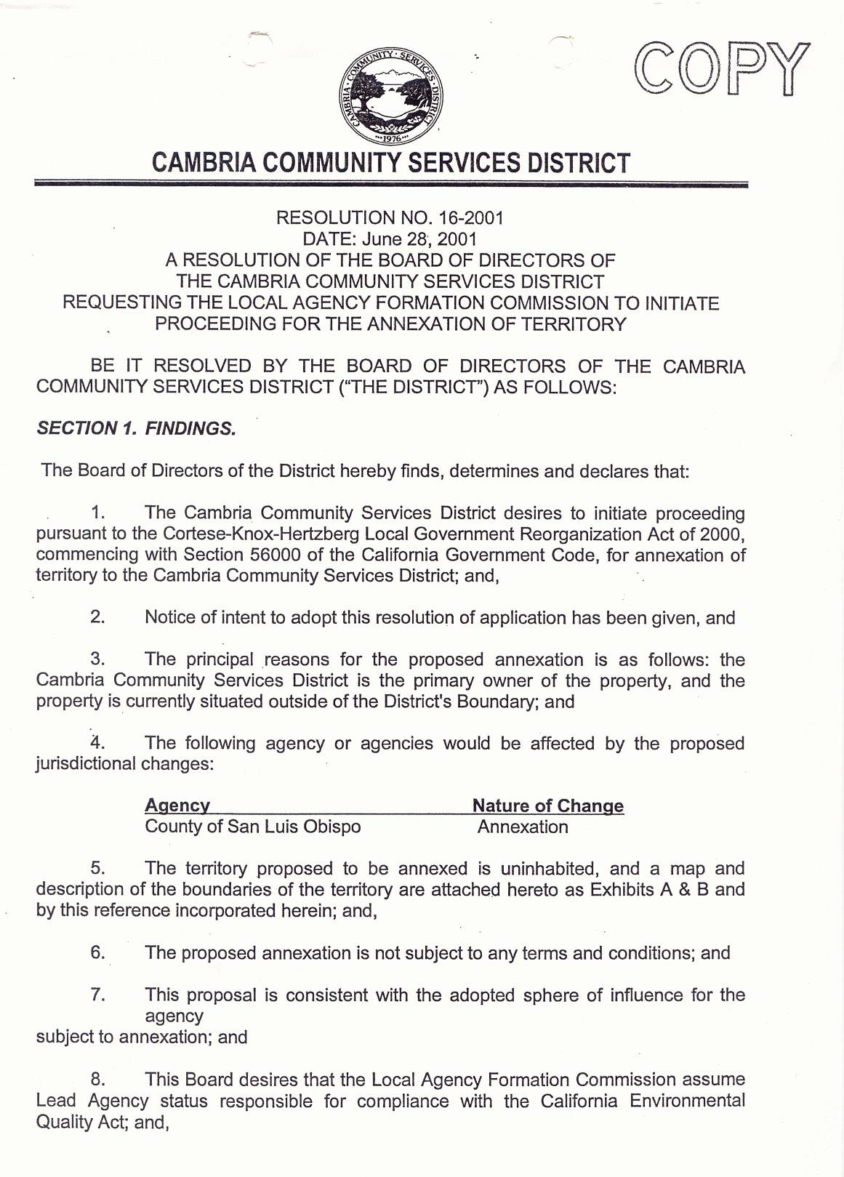SAMPLE D
UPDATED: AUGUST 2021 36
SAMPLE RESOLUTION OF APPLICATION
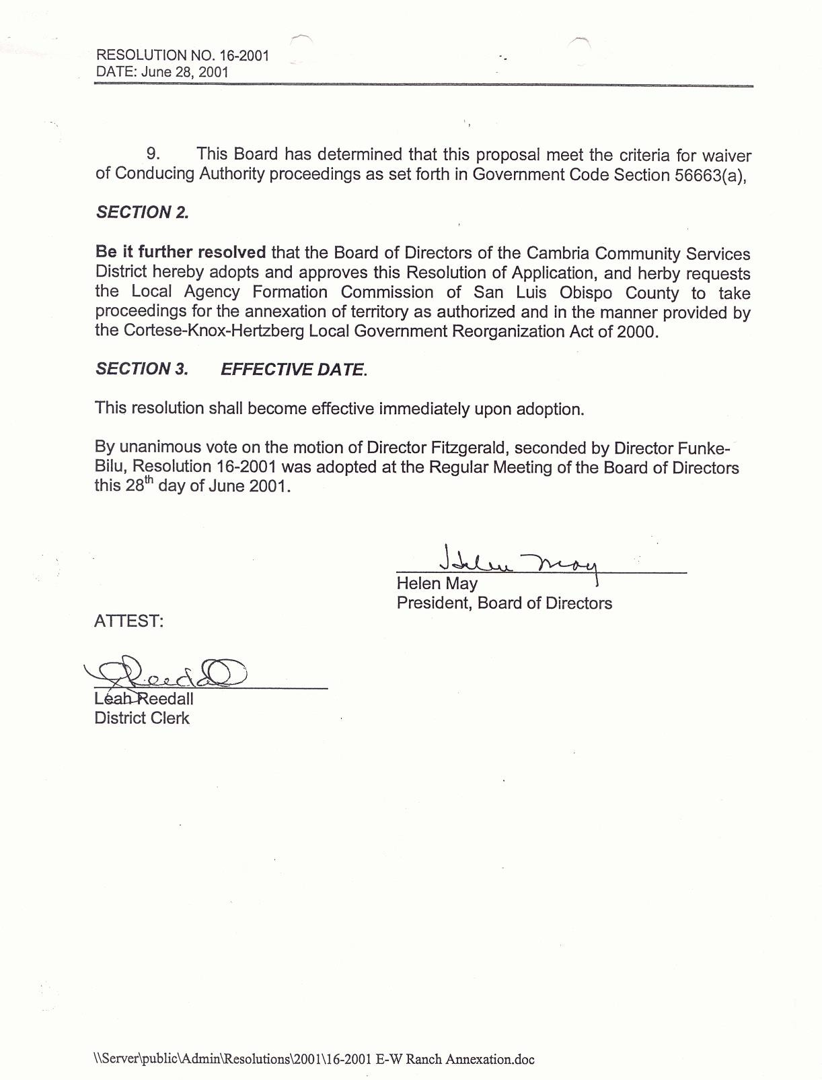

SAMPLE E
SAMPLE LETTER OF CONSENT

NOTE: Please specify if the consent letter submitted includes 100% of property owners. If 100% of the property are in favor of the annexation the protest process can be waived. All the property owners must sign the consent letter.

To: San Luis Obispo Local Agency Formation Commission 1042 Pacific Street, Suite A
San Luis Obispo, CA 93401 Date:

LAFCO Commissioners,

This Letter of Consent will serve to notify you of our approval of the annexation of territory to: (name project)

that includes the property list below:

Assessor’s Parcel Numbers:

