

Public Review Draft Draft

Santa Margarita Fire Protection District

Municipal Service Review

and Sphere of Influence Study

Prepared by
The San Luis Obispo Local Agency Formation Commission

Adopted ___, 2025

Resolution No. ____

TABLE OF CONTENTS
About LAFCO 4
Authority and Objectives 4
Regulatory Responsibilities 4
Planning Responsibilities 5
LAFCO Decision-Making 6
SLO LAFCO 7
Acknowledgments 8
District MSR & Sphere Study 9
Overview 9
At A Glance 10
Background 10
Sphere of Influence & Service Area Boundary 11
Population Profile 12
Present and Planned Land Use 16
Accountability 17
Finance 18
Services & Capacity 23
Shared Facilities & Other Matters Related to Efficient Service Delivery 29
Determinations 33
Municipal Service Review Determinations 33

List of Figures
Figure 1: SMFPD Service Area Boundary 11
Figure 2: SOI Amendment & Annexation No. 1 to CSA 23 Vicinity Map, SMR Subdivision 13
Figure 3: Santa Margarita DUC Map 15
Figure 4: Land Use Designations within SMFPD 17
Figure 5: Revenues vs. Expenditures 20
Figure 6: Operating Ratio (FY 2019-2020 to FY 2023-2024) 20
Figure 7: Liquidity Ratio (FY 2019-2020 to FY 2023-2024) 22
Figure 8: Heat Map of Incident Locations in SMFPD 26
Figure 9: SMFPD Response Times 27
Figure 10: Surrounding Station Response Times 28
Figure 11: Proposed Relocation Site for County Fire Engine 40 30

List of Tables
Table 1: District Profile 10
Table 2: SMFPD Board of Directors 17
Table 3: SMFPD Property Tax Allocation 19
Table 4: Audited Assets 21
Table 5: Audited Liabilities 22
Table 6: Audited Net Position 23
Table 7: SMFPD Apparatus Inventory 29

About LAFCO

Authority and Objectives
Local Agency Formation Commissions (LAFCOs) were established in 1963 and are considered regional subdivisions of the State of California responsible for providing regional growth management services in all 58 counties. LAFCOs’ authority is codified under the Cortese-Knox-Hertzberg Local Government Reorganization Act of 2000 (CKH), with principal oversight provided by the Assembly Committee on Local Government. LAFCOs are comprised of locally elected and appointed officials with regulatory and planning powers delegated by the Legislature to coordinate and oversee the establishment, expansion, and organization of cities and special districts and their municipal service areas.

Regulatory Responsibilities
LAFCOs’ principal regulatory responsibility involves approving or disapproving all jurisdictional changes involving the establishment, expansion, and reorganization of cities, towns, and most special districts in California. The Government Code defines “special district” to mean any agency of the State formed pursuant to general law or special act for the local performance of governmental or proprietary functions within limited boundaries. All special districts in California are subject to LAFCO oversight with the following exceptions: school districts, community college districts, assessment districts, improvement districts, community facilities districts, and air pollution control districts. LAFCOs are also tasked with overseeing the approval process for cities and special districts to provide new or extended services beyond their jurisdictional boundaries through contracts, agreements, or annexation. LAFCOs also oversee special district actions to either activate new service functions and service classes or divest existing services. LAFCOs generally exercise their regulatory authority in response to applications submitted by affected agencies, landowners, or registered voters. Recent amendments to the Government Code also authorize and encourage LAFCOs to initiate jurisdictional changes to form, consolidate, and dissolve special districts consistent with community needs.

Planning Responsibilities
LAFCOs inform their regulatory actions, in part, through two central planning responsibilities: (a) making sphere of influence determinations and (b) preparing municipal service reviews. With these reports and other relevant information in the record, LAFCO makes decisions on a variety of matters, including but not limited to annexations to cities and special districts, city incorporations, activation of powers for special districts, dissolutions of special districts, etc.
Sphere of Influence
A Sphere of Influence (SOI) is defined by Government Code Section 56425 as a plan for the probable physical boundary and service area of a local agency or municipality. An SOI is generally considered a 20-year, long-range planning tool. LAFCOs establish, amend, and update spheres for all applicable jurisdictions in California every five years, or as necessary. When updating an SOI, LAFCOs are required to consider and prepare a written statement of their determinations concerning each of the following five factors:
- The present and planned land uses in the area, including agricultural and open-space lands.
- The present and probable need for public facilities and services in the area.
- The present capacity of public facilities and adequacy of public services that the agency provides or is authorized to provide.
- The existence of any social or economic communities of interest in the area if the commission determines that they are relevant to the agency.
- For an update of a sphere of influence of a city or special district that provides public facilities or services related to sewers, municipal and industrial water, or structural fire protection, that occurs pursuant to subdivision (g) on or after July 1, 2012, the present and probable need for those public facilities and services of any disadvantaged unincorporated communities within the existing sphere of influence.
The intent in preparing the written statements is to orient LAFCOs in addressing the core principles underlying the sensible development of local agencies consistent with the anticipated needs of the affected communities.

Municipal Service Reviews
Municipal Service Reviews (MSR), in contrast, are intended to inform, among other activities, SOI determinations. LAFCOs also prepare MSRs regardless of making any specific sphere determinations in order to obtain and furnish information to contribute to the overall orderly development of local communities. When updating an MSR, LAFCOs are required to consider and prepare written statements of their determinations concerning each of the following seven factors:
- Growth and population projections for the affected area.
- The location and characteristics of any disadvantaged unincorporated communities within or contiguous to the sphere of influence.
- Present and planned capacity of public facilities, adequacy of public services, and infrastructure needs or deficiencies, including needs or deficiencies related to sewers, municipal and industrial water, and structural fire protection in any disadvantaged, unincorporated communities within or contiguous to the sphere of influence.
- Financial ability of agencies to provide services.
- Status of, and opportunities for, shared facilities.
- Accountability for community service needs, including governmental structure and operational efficiencies.
- Any other matter related to effective or efficient service delivery, as required by commission policy.

LAFCO Decision-Making
LAFCO decisions are legislative in nature and, therefore, are not subject to an outside appeal process; only courts can overturn LAFCO decisions. LAFCOs also have broad powers with respect to conditioning regulatory and planning approvals, so long as not establish any terms that directly affect land use density or intensity, property development, or subdivision requirements.

LAFCOs are generally governed by a board comprised of county supervisors, city council members, independent special district members, a representative of the general public, and an alternate member for each category. SLO LAFCO is governed by a seven-member board comprised of two county supervisors, two city council members, two independent special district members, one representative of the general public, and an alternate member for each category. All members serve four-year terms and must exercise their independent judgment on behalf of the interests of residents, landowners, and the public as a whole. LAFCO members are subject to standard disclosure requirements and must file annual statements of economic interests. LAFCOs are independent of local government with their own staff. All LAFCOs, nevertheless, must appoint their own Executive Officers to manage agency activities and provide written recommendations on all regulatory and planning actions before the Commission. In addition, all LAFCOs must also appoint their own legal counsel.

SLO LAFCO
Regular Commissioners
Chair Steve Gregory | City Member
Vice Chair Heather Moreno | County Member
Dawn Ortiz-Legg | County Member
Ed Waage | City Member
Edy Eby  Navid Fardanesh | Special District Member  Special District Member
David Watson | Public Member
Alternate Commissioners
Bruce Gibson | County Member
Carla Wixom | City Member
Vacant | Special District Member
Michael Draze | Public Member
Staff
Rob Fitzroy | Executive Officer
Imelda Marquez-Vawter | Analyst
Morgan Bing | Analyst
Melissa Morris | Commission Clerk
Holly Whatley | Legal Counsel

Contact Information
San Luis Obispo LAFCO’s office is located at 1042 Pacific St, Suite A, in the City of San Luis Obispo. The LAFCO office is open by appointment to discuss proposals or other matters and can be scheduled by calling 805-781-5795. Additional information is also available online by visiting slo.lafco.ca.gov.

Acknowledgments
San Luis Obispo LAFCO gratefully acknowledges the time and effort of staff with the Santa Margarita Fire Protection District in assisting with the preparation of this report, and includes, but is not limited to, the following:

Chief Robert Murach

District MSR & Sphere Study

Overview
This report represents San Luis Obispo LAFCO’s scheduled Municipal Service Review (MSR) for the Santa Margarita Fire Protection District (SMFPD or District), located in the eastern portion of San Luis Obispo County (County). The report has been prepared by staff in accordance with the requirements of the Government Code. The purpose of this report is to produce an independent assessment of municipal services in this area over the next five years or as necessary, relative to the Commission’s regional growth management duties and responsibilities as established by the State Legislature. This includes evaluating the current and future relationship between the availability, demand, and adequacy of municipal services within the service areas of the SMFPD, subject to the Commission’s oversight. The information generated as part of the report will be used by the Commission in (a) guiding subsequent sphere of influence updates, (b) informing future boundary changes, and – if merited – (c) initiating government reorganizations, such as special district formations, consolidations, and/or dissolutions.
The period for collecting data to inform the Commission’s analysis and related projections on population growth and service demands has been set to cover any major updates and changes since the last time the MSR was updated in 2014. The financial analysis has been set to cover the last five-year audited fiscal year period. The timeframe for the report has been generally oriented to cover the next five to seven-year period, with the former (ten years) serving as the analysis anchor as contemplated under State law.
The document outline serves to inform all the state-mandated requirements outlined in Government Code Sections 56430 and 56425. Written determinations have been included as the concluding chapter of this document.

At A Glance
Table 1: District Profile
Agency Name | Santa Margarita Fire Protection District
Formation | 1921
Office Location | 22375 El Camino Real, Santa Margarita, CA 93453
Website | https://santamargaritafiredept.org/
Types of Services | Fire Protection and Suppression Service & Medical Response
Chief Officers | Robert Murach, Fire Chief  Bobby Guy, Deputy Fire Chief
Number of Staff | 16 Paid Call Firefighters
Apparatus | 3
District Service Area | 307 acres (0.5 square miles)
Population Served | 1,291 residents
Public Meetings | The Board of Directors meets on the second Wednesday of each month at 5:00 PM at 22375 El Camino Real, Santa Margarita, CA 93453
Board of Directors | Three members elected to four-year terms

Background
Fire Protection Districts are authorized under Section 13800 of the California Health and Safety Code to provide a range of emergency response services, including wildfire and community (structure) fire protection, medical aid, technical rescue, hazardous materials containment and control, and general public assistance responses. From a statewide perspective, over the past 50 years, changes in the level of service provided by fire protection districts and policy changes at the federal and state levels have exponentially increased the cost of providing fire service. The impact of unfunded mandates is evident in increasing labor costs, service and supply costs, and capital facilities and equipment costs. Fire service costs are primarily recovered through property taxes and fees for service; however, despite increases in the level of service and the growing costs to provide that service, mechanisms available to fire protection districts for recovering costs have not been responsive to these increases. While special taxes and assessments are available, they are difficult to implement and unreliable for long-term planning. Funding shortages have led to brownouts, increased response times, and deferred capital projects.
Many of the same fire service challenges experienced statewide are also present within San Luis Obispo County. Previously, there were ten fire protection districts in the County; however, at this time, the Santa Margarita Fire Protection District (SMFPD) is the single remaining fire protection district. The District was formed by petition and County Board of Supervisors resolution in 1921 with the purpose of providing fire protection services to the community of Santa Margarita. SMFPD was inactive or operating at minimal service levels between 1925 and 1949. Since 1949, the District has provided volunteer fire protection to District residents. The following report provides a discussion on SMFPD’s present and long-term service demands and resource capabilities in the context of the broader funding and service-related challenges and constraints experienced by fire protection districts throughout the state.

Sphere of Influence & Service Area Boundary
SMFPD’s existing Sphere of Influence (SOI), last adopted in November 2014, is coterminous with its service area boundary and is depicted in Figure 1 below. The District covers approximately 307 acres and includes the urban area of Santa Margarita.
Figure 1: SMFPD Service Area Boundary
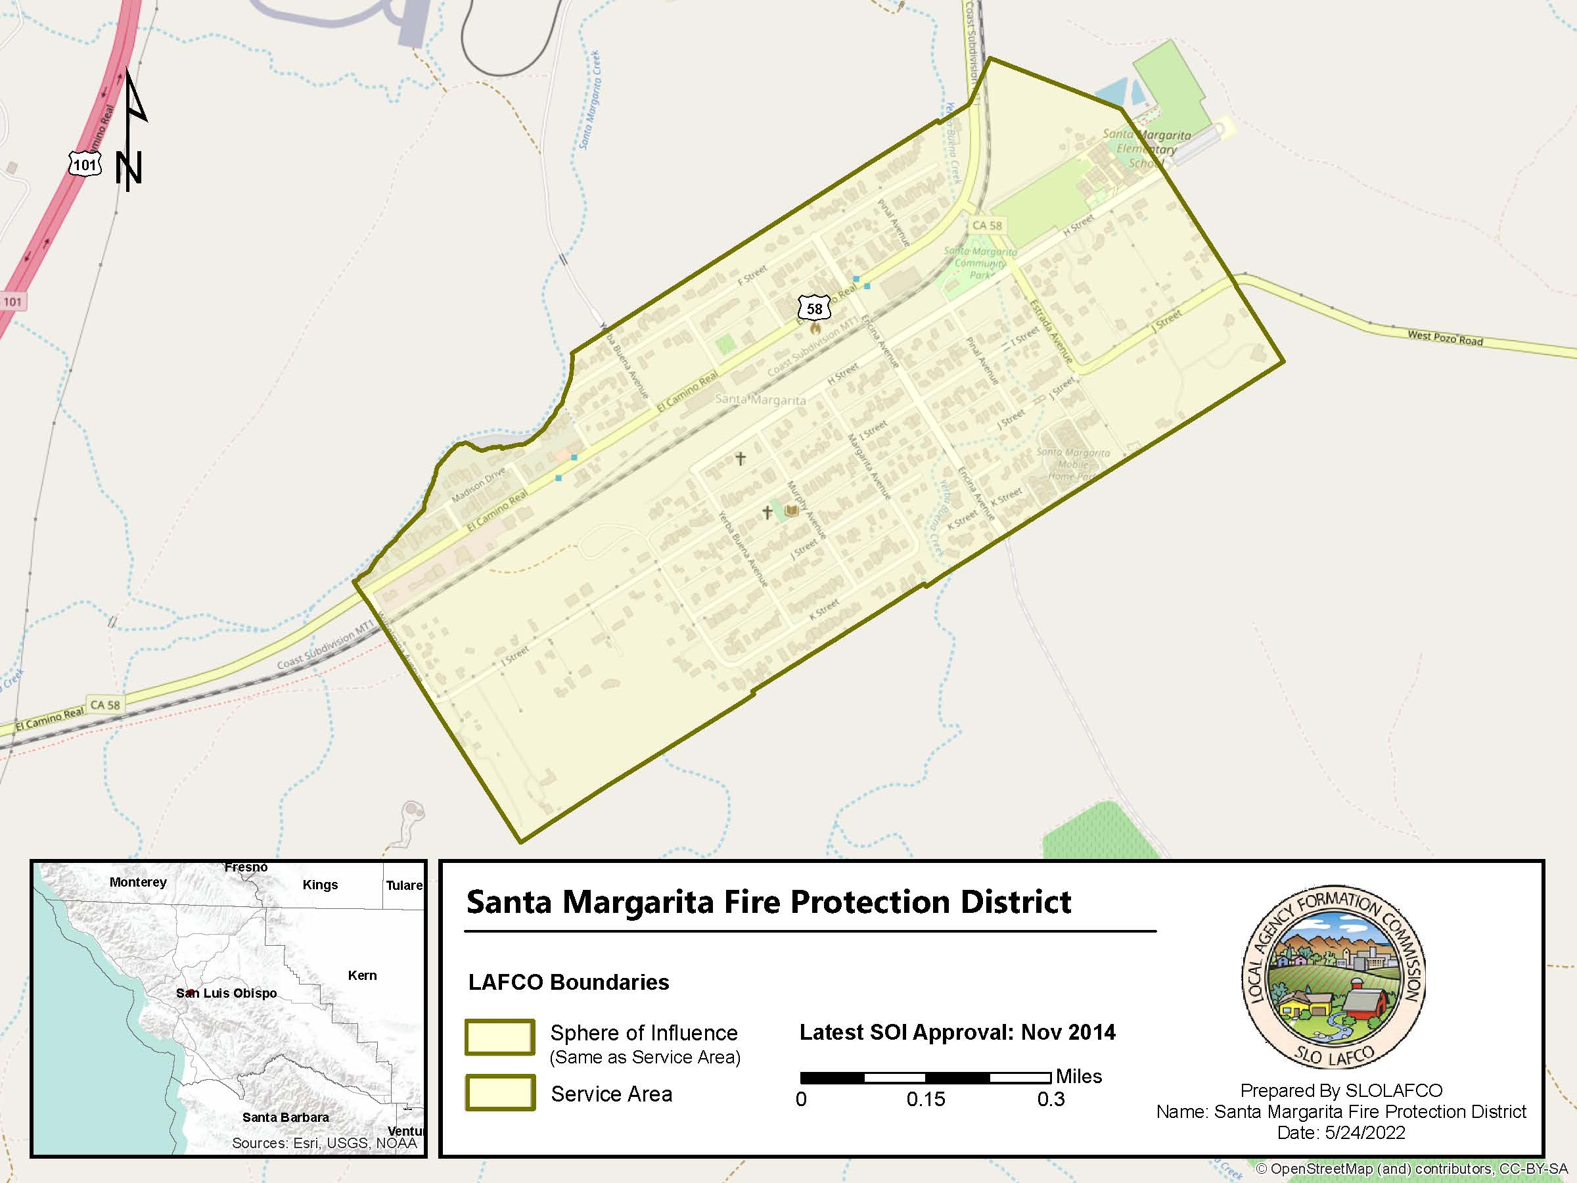

Population Profile
Based on the 2020 Census data, the Santa Margarita Census Designated Place (CDP), which closely coincides with the SMFPD and County Service Area 23 (CSA 23) service area boundaries, has an estimated population of 1,291 and approximately 564 total housing units. The build-out population, defined as the maximum population that can occur considering zoning and land use designations, is estimated to be 1,466, with an estimated buildout year of 2050.

On January 16, 2025, LAFCO approved an SOI amendment and annexation of the Santa Margarita Ranch Agricultural Residential Cluster Subdivision Project (SMR Subdivision) into CSA 23. The SMR Subdivision is 143 acres, consisting of 111 residential parcels located southeast of the SMFPD and CSA 23 and south of Highway 58 (See Figure 2). This action did not augment the SMFPD boundary, and as such, the SMR Subdivision is not within the formal service area boundary of the SMFPD. The Environmental Impact Report prepared for the SMR Subdivision used a population generation factor of 2.7 persons per household to project a population of approximately 300 residents at full buildout of the 111 residential lots. Full buildout is expected to occur in 2032-2034. This represents an approximate 23.2% increase in the existing population of the Santa Margarita community. Although this development will occur outside of the SMFPD service area boundary, due to the isolated location of the SMR Subdivision with no close County Fire stations or other nearby fire agency neighbors, the SMFPD would likely be the first fire agency to respond to the SMR Subdivision through Automatic Aid Agreements. Potential impacts to SMFPD’s service capacity are further discussed in the Shared Facilities & Other Matters Related to Efficient Service Delivery Section.
Figure 2: SOI Amendment & Annexation No. 1 to CSA 23 Vicinity Map, SMR Subdivision
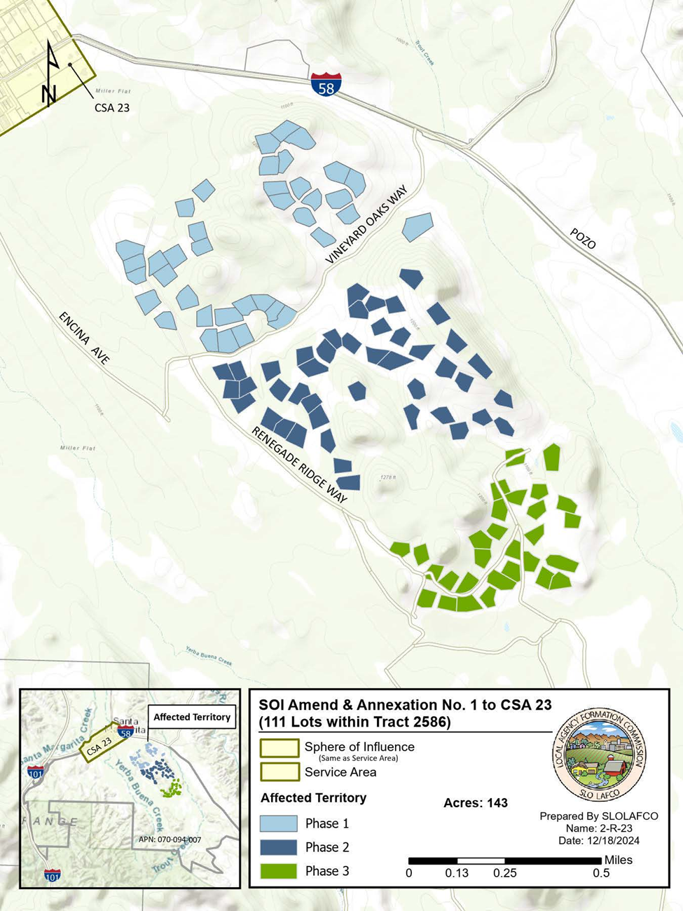

Disadvantaged Unincorporated Communities
LAFCO is required to evaluate Disadvantaged Unincorporated Communities (DUCs) as part of this MSR, including the location and characteristics of any such community. Per California Senate Bill 244, a DUC is defined as any area with 12 or more registered voters where the median household income (MHI) is less than 80 percent of the statewide MHI. The legislative intent is to prohibit selective annexations by cities of tax-generating land uses while leaving out underserved, inhabited areas with infrastructure deficiencies and a lack of access to reliable potable water, wastewater, and fire protection services. SMFPD provides fire protection service and is responsible for ensuring that this service is adequately provided to the community.

To identify the MHI for locations within the unincorporated areas of the County, and to identify those that meet the DUC MHI threshold, LAFCO used U.S. Census American Community Survey (ACS) five-year reports for Census Block Groups (CBG) and Census Designated Places (CDP) data. Once a CBG or a CDP meets the DUC MHI threshold, LAFCO then verifies that those areas are inhabited as specified in Government Code Section 56033.5 using registered voter data from the County Clerk-Recorder.

The estimated MHI for Census Block Group 127.05.3, which encompasses the entirety of the Community of Santa Margarita and neighboring rural areas, is $50,625, which is less than 80 percent of the statewide MHI in 2020 of $84,097. Census Block Group 127.05.3 was also determined to be inhabited, with approximately 1,189 registered voters. Therefore, LAFCO identified one DUC at the CBG level, located within and contiguous to SMFPD’s coterminous SOI and service area boundaries as seen in Figure 3 below. It should be noted that the SMFPD SOI and service area boundary is surrounded by a single property owner (the Santa Margarita Ranch), and the identified DUC includes some agriculture-zoned areas with no registered voters. Should the District seek to evaluate the surrounding area for annexation, disadvantaged communities should be considered further.

Social or Economic Communities of Interest in the Area
There are no district-relevant social or economic communities of interest in the area served.

Figure 3: Santa Margarita DUC Map
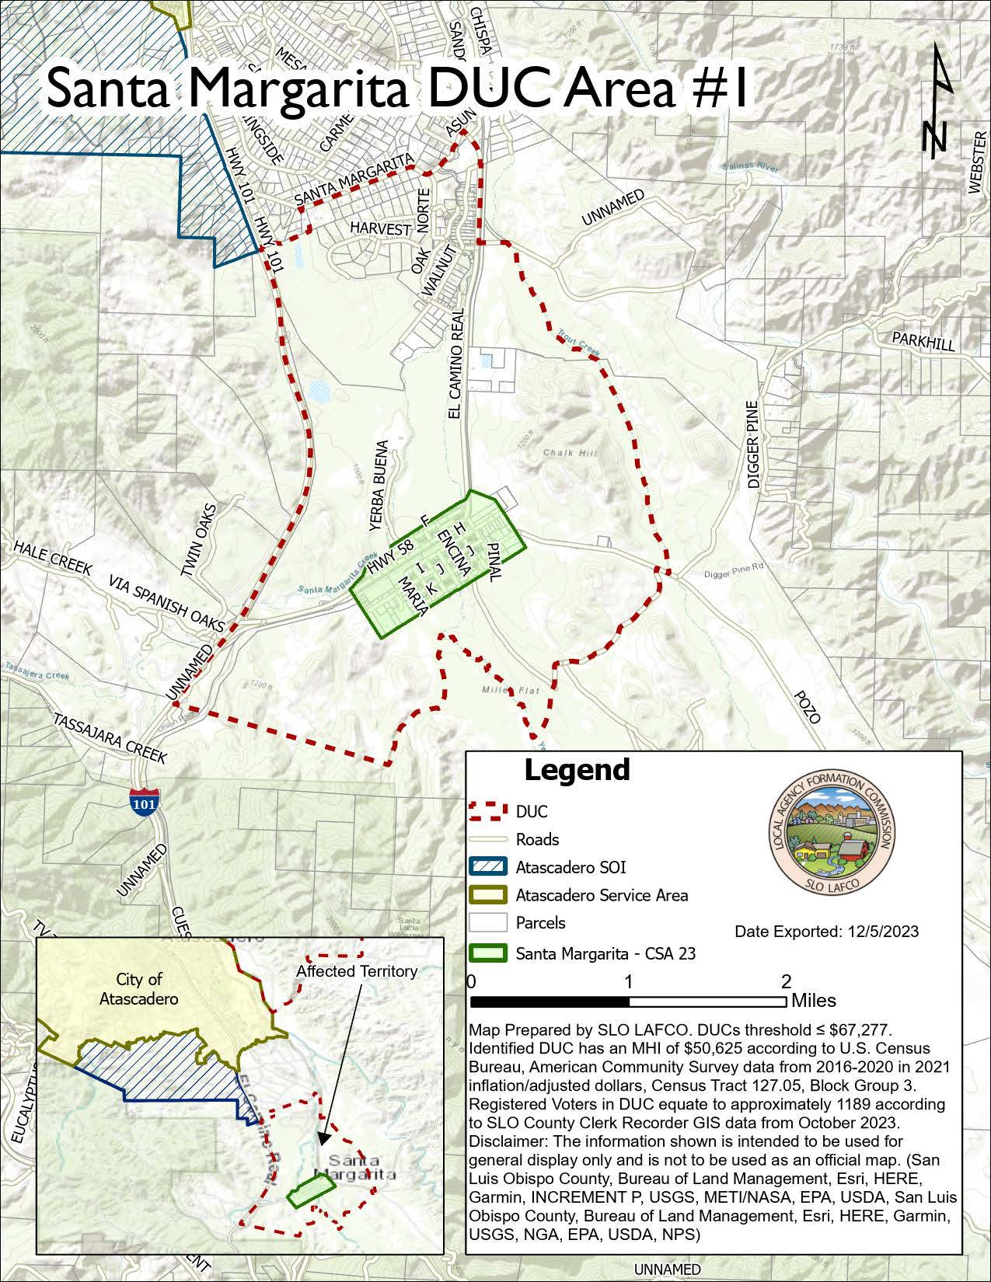

Present and Planned Land Use
Land uses within the SMFPD boundaries are subject to the Santa Margarita Community Plan adopted in February 2014, which is Part III of the Land Use and Circulation Element of the County General Plan. This plan is consistent with the other elements of the County’s General Plan. All other County plans, policies, and programs that involve the community of Santa Margarita and are subject to the County General Plan are to be consistent with and implement this plan. The location and distribution of the land uses within the District are presented below in Figure 4.

The community of Santa Margarita is close to being built out in its residential areas. Although it has enough land designated for a 100 percent increase in commercial development, commercial development is expected to be slow. The primary land use designations within the District are Residential Suburban and Residential Single Family. The SMFPD does not contain any land within the Agriculture or Open Space land use categories.

As stated in previous sections, on January 16, 2025, LAFCO approved an SOI amendment and annexation of the SMR Subdivision into CSA 23. The SMR Subdivision is 143 acres, consisting of 111 residential parcels located southeast of the SMFPD and CSA 23 and south of Highway 58 (See Figure 2 above). The zoning will remain within the agricultural land use category. This action did not augment the SMFPD boundary, and as such, the SMR Subdivision is not within the formal service area boundary of the SMFPD (more details on this topic are discussed in the Shared Facilities & Other Matters Related to Efficient Service Delivery Section).
Figure 4: Land Use Designations within SMFPD
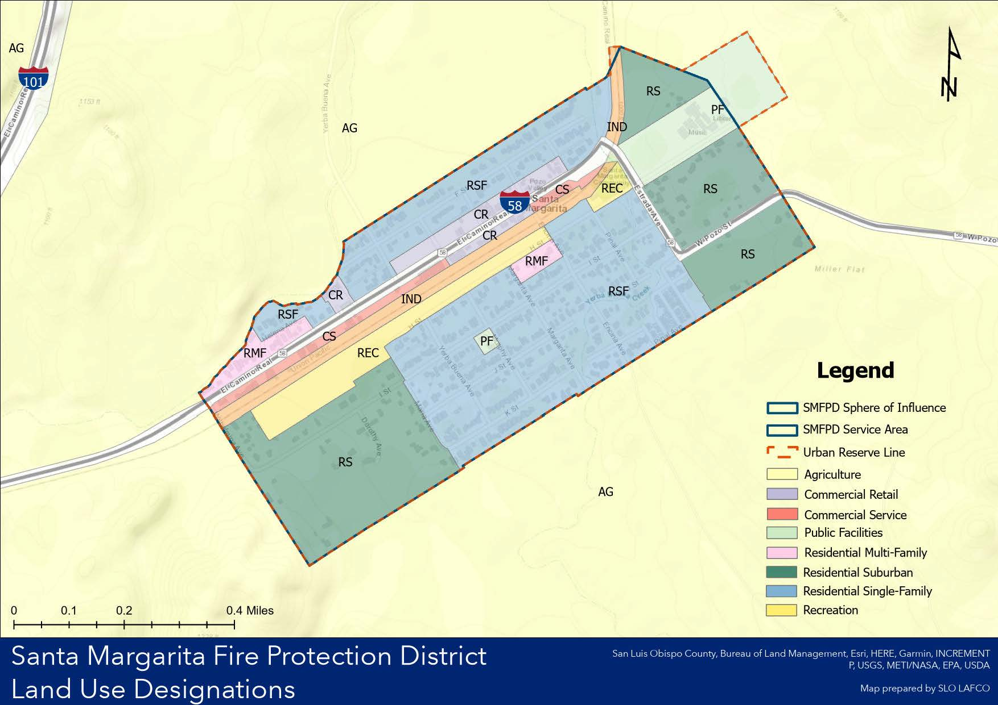

Accountability
SMFPD’s governance authority is established under the Fire Protection District Law of 1961 and codified under Public Health and Safety Code Sections 13800. Governance of SMFPD is independently provided by a three-member Board of Directors that is elected to four-year terms, see Table 2. District elections have largely gone uncontested for the last several election cycles. The Board of Directors meets on the second Wednesday of each month at 5:00 PM at 22375 El Camino Real, Santa Margarita, CA 93453.
Table 2: SMFPD Board of Directors
Board Member | Title | Term Expiration
John Wilkins | President | December 2028
Beth Gorrill | Secretary | December 2026
Joel Switzer | Director | December 2026
The District’s agendas, board packets, minutes, and financial reports are posted on the fire station window and made publicly available upon request. To maintain compliance with Senate Bill 929, the Brown Act, and increase transparency to the community, the District is encouraged to maintain an up-to-date website and annually update an SB 272 Enterprise System Catalog.

Finance
LAFCO is required to make determinations regarding the financial ability of the SMFPD to provide public services. This section provides a general overview of financial health and provides a context for the financial determinations. LAFCO uses three financial indicators to help evaluate the District’s general health; those are an assessment of Revenues & Expenditures (Operating Ratio), Assets and Liabilities (Liquidity Ratio), and Net Position. The audited financial statement reports from the District for the fiscal years (FY) 2019-2020 through FY 2023-2024 are the primary source of information for this section.

Budget
The District Board of Directors adopts an annual budget on a basis consistent with generally accepted accounting principles. After the budget is approved, the appropriations can be added to, subtracted from, or changed only by a Board resolution. All such changes must be within the revenues and reserves estimated as available in the final budget or within revised revenue estimates as approved by the Board. The District’s annual budgets show revenues at least equal to expenditures without relying on reserves.
Audited Financial Statements
SMFPD hires an outside accounting firm to perform an annual audit in accordance with established governmental accounting standards. This includes auditing SMFPD’s financial statements with respect to verifying overall assets, liabilities, and net position. These audited statements provide quantitative measurements in assessing SMFPD’s short and long-term fiscal health with a specific focus on delivering its active service functions. LAFCO has used the five most recent audited financial statements to conduct its evaluation of the District’s Financial Health, separated into four categories (Revenues and Expenditures, Agency Assets, Agency Liabilities, and Agency Net Position). Financial Conclusions have also been included, based on the most recent audited Fiscal Year ending on June 30, 2024.

Revenues and Expenditures
The District is primarily funded through property taxes. Table 3 below depicts the property tax growth trend in SMFPD over the last five years. The District has a comparatively low assessed value and a small number of parcels, resulting in slow growth of revenue and limited potential for revenue generation opportunities through benefit assessment.
Table 3: SMFPD Property Tax Allocation
Fiscal Year | 2019-2020 | 2020-2021 | 2021-2022 | 2022-2023 | 2023-2024
Property Tax Allocation | $117,630 | $120,453 | $133,163 | $142,285 | $148,084
Growth % | 2.77% | 2.4% | 10.55% | 6.85% | 4.08%

The number of parcels in the District impacts the ability of the District to pass a parcel-based benefit assessment fee. In 2018, an analysis was conducted to determine the fee burden per parcel based on generating an arbitrary amount of $500,000 in revenue for the District. With approximately 522 parcels, a flat fee of $961 per parcel (all parcels charged the same amount) is required to generate $500,000 in the SMFPD. Values may vary depending on the number of exempt parcels.

In addition to property tax, District revenues also include public facility fees, ambulance reimbursements, interest income, grants, and donations. To date, SMFPD has been successful in obtaining grants for new equipment and donations of used fire apparatus. As shown in Figure 5 below, the District has experienced an overall increase in revenues from FY 2019-2020 to FY 2023-2024. Similarly, the District’s total expenditures have experienced an overall increase in the last five fiscal years, largely related to increases in the cost of services and supplies. Additionally, in October 2020, the District began to make monthly payments of principal and interest on a $170,000 loan for a new fire engine. The District does not have adequate annual revenue to set aside funds in a sinking fund account for the replacement of fire apparatus and equipment.
Figure 5: Revenues vs. Expenditures

Figure 6 presents SMFPD’s operating ratios over the last five audited years, which measure the ratio of annual operating revenues to annual operating expenses. Operating ratio is used as an indicator of the District’s financial health. A ratio of 1.0 means the agency is breaking even, a ratio of less than 1.0 indicates insufficient operating revenue to cover operating expenses, and a ratio greater than 1.0
means an agency can pay all its operating expenses and has revenue left over to spend on other items.
Figure 6: Operating Ratio (FY 2019-2020 to FY 2023-2024)

Agency Assets & Liabilities
An agency’s assets provide current, future, or potential economic benefit for the entity. An agency asset is, therefore, something that is owned by the agency or something that is owed to the agency. In this section, agency assets will be reviewed in two separate categories as defined below:

- Current Assets: cash and other assets that are expected to be converted to cash within a year
- Capital Assets: long-term investments that are not expected to become cash within an accounting year

SMFPD’s audited assets at the end of FY 2023-2024 totaled $731,602 and are 5.6% higher than the average year-end amount of $692,488 documented during the previous five-year audited period. Assets classified as current, with the expectation they could be liquidated within a year, represented 49% of total assets, or $361,825, and are primarily associated with cash and cash equivalents. Assets classified as capital assets make up the remainder of the total and are primarily attributed to equipment and land. Overall, District assets have increased by 26% over the corresponding 5-year audited period.
Table 4: Audited Assets
 | FY 19-20 | FY 20-21 | FY 21-22 | FY 22-23 | FY 23-24 | 5-yr % Change | 5-yr Average
Current Assets | $388,623 | $291,353 | $277,007 | $324,857 | $361,825 | -6.90% | $328,733
Capital Assets | $190,315 | $471,165 | $414,375 | $373,142 | $369,777 | 94.30% | $363,755
Total Assets | $578,938 | $762,518 | $691,382 | $697,999 | $731,602 | 26.37% | $692,488

An agency’s liability is something the agency owes, usually a sum of money. Liabilities are settled over time through the transfer of economic benefits, including money, goods, or services. In this section, agency liabilities will be reviewed in two separate categories as defined below:

- Current Liabilities: are an agency's short-term financial obligations due to be paid within a year.
- Other Non-Current Liabilities: are an agency’s long-term financial obligations that are due more than a year away.

SMFPD’s audited liabilities at the end of FY 2023-2024 totaled $98,237 and were 6.3% lower than the average year-end amount of $104,815 documented during the previous five-year audited period. This is largely due to decreases in the District’s long-term liabilities related to a loan for a new fire engine. Liabilities classified as current, which represent obligations owed in the near term, account for 46%, or $45,094, of the total liabilities. Non-current liabilities represent the remaining total, or $53,143, and are largely tied to payment of liabilities due after one year. Overall liabilities have increased significantly by 1,181% over the corresponding 5-year audited period.
Table 5: Audited Liabilities
 | FY 19-20 | FY 20-21 | FY 21-22 | FY 22-23 | FY 23-24 | 5-yr % Change | 5-yr Average
Current Liabilities | $7,664 | $15,989 | $15,787 | $18,041 | $45,094 | 488% | $20,515
Non-Current Liabilities | - | $145,533 | $130,563 | $92,259 | $53,143 | 63.48% | $105,375
Total Liabilities | $7,664 | $161,522 | $146,350 | $110,300 | $98,237 | 1,181% | $104,815

Figure 7 presents the District’s liquidity ratio over the last five-year audited period, which measures current assets against current/near-term obligations. The liquidity ratio is another indicator of the District’s financial health. A ratio of less than 1.0 indicates insufficient short-term resources to cover short-term liabilities, and anything over 1.0 indicates good financial health (the higher the number, the greater the degree of liquidity).
Figure 7: Liquidity Ratio (FY 2019-2020 to FY 2023-2024)

Agency Net Position
The government-wide financial statements also utilize a net position presentation. Net position is the difference between assets and liabilities and is one way to measure the District’s financial health or financial position. Overtime increases or decreases in the District’s net assets are one indicator of whether its financial health is improving or deteriorating. SMFPD’s audited net position at the end of FY 2023-2024 totaled $633,365 and is 7.7% higher than the five-year average amount of $587,673. A portion of the District’s net position, 58%, reflects its net investment in capital assets (e.g., land and equipment), with the remainder categorized as unrestricted. Overall, the District’s net position has increased by 10.87% over the corresponding 5-year audited period.
Table 6: Audited Net Position
Category | FY 19-20 | FY 20-21 | FY 21-22 | FY 22-23 | FY 23-24 | 5-yr % Change | 5-yr Average
Net Investment in Capital Assets | $190,315 | $471,165 | $414,375 | $373,142 | $369,777 | 94.30% | $363,755
Unrestricted | $380,959 | $129,831 | $130,657 | $214,557 | $263,588 | -30.81% | $223,918
Total Net Position | $571,274 | $600,996 | $545,032 | $587,699 | $633,365 | 10.87% | $587,673

Services & Capacity
Active Services
SMFPD’s governance authority is established under the Fire Protection District Law of 1987 and codified under Public Health and Safety Code Sections 13800. This principal act identifies a range of services that a fire protection district may provide, and a complete listing of the powers afforded to fire protection districts is located in Public Health and Safety Code Sections 13860 - 13879. Authorized services granted to fire protection districts under current law include, but are not limited to:
- Fire protection services
- Rescue services
- Emergency medical services
- Hazardous material emergency response services
- Ambulance Services
- Any other services related to the protection of lives and property
- A district may enter into a mutual aid agreement with any federal or state agency, any city, county, special district, or federally recognized Indian tribe
Government Code Section 56425 (i) provides that “when adopting, amending, or updating a sphere of influence for a special district, the commission shall establish the nature, location, and extent of any functions or classes of services provided by existing districts.” Government Code Section 56050.5 defines a latent service or power as “those services, facilities, functions, or powers authorized by the principal act under which the district is formed, but that are not being exercised, as determined by the commission pursuant to subdivision (i) of Government Code Section 56425.” Therefore, once the Commission has established what services are being provided pursuant to § 56425 (i), all other services, functions and powers become “latent services or powers” by operation of law. The SMFPD is authorized to exercise all powers listed in Public Health and Safety Code Sections 13860 - 13879; as such, there are no powers that are considered latent by operation of law.

The MSR and SOI Study provides discussion on present and long-term service demands and resource capabilities of the local agency. LAFCO reviews and evaluates 1) the resources and services that are currently available, and 2) the ability of the SMFPD to expand such resources and services in line with increasing demands. An adequate ability to provide service should be documented to support areas in the sphere envisioned for eventual annexation and service by a jurisdiction. If warranted, different governance options may be reviewed for the District, including potential jurisdictional changes such as consolidation, reorganization, and dissolution.
Staffing & Personnel
SMFPD is dependent on community members volunteering for Paid Call Firefighter (PCF) and Fire Officer positions. The District has no career firefighters, and there are no firefighters on duty at the fire station; however, PCFs must live within a five-minute response time to the District. The depth of staffing for volunteer fire companies is important to provide a reliable response and sufficient depth of force to mitigate incidents safely. The Insurance Service Office uses a ratio of three volunteers on the roster to generate one responder. The SMFPD consists of 1 PCF Chief, 1 PCF Deputy Chief, 1 PCF Captain, 1 PCF Lieutenant, and 12 Paid Call Firefighters. Given the total of 16 active volunteers, the District should be able to achieve two to three volunteers per call, depending on all of the factors that affect volunteer availability. A higher number on the roster, so that the District could meet the 2 in 2 out requirements for respiratory protection on structural fires, would suggest a roster of at least 12 or more to fill key fire ground roles.

To date, the District reports success with recruiting and retaining PCFs; however, sustainability of the current staffing model for the next five to ten years is predicated on the ability to recruit and retain PCFs and develop experienced PCF staff into fire officers. If PCF recruitment is unsustainable in the future, and there is a need to provide full-time career staff, SMFPD will need to seek additional revenue, most likely through a benefit assessment.
Service Delivery & Performance
In 2024, the District responded to 200 total incidents. The District contracts with County Fire for dispatch services, and the majority of calls received by the SMFPD are for medical emergencies and public assistance. The following map, prepared by County Fire, represents the density of incidents in a given location of the District, known as a “heat map”. The District boundary is represented by a red line. The shades of purple and blue represent incidents at that location. Light shades indicate few calls for service at that location, while the deep purple represents a high volume of calls at the same location.
Figure 8: Heat Map of Incident Locations in SMFPD
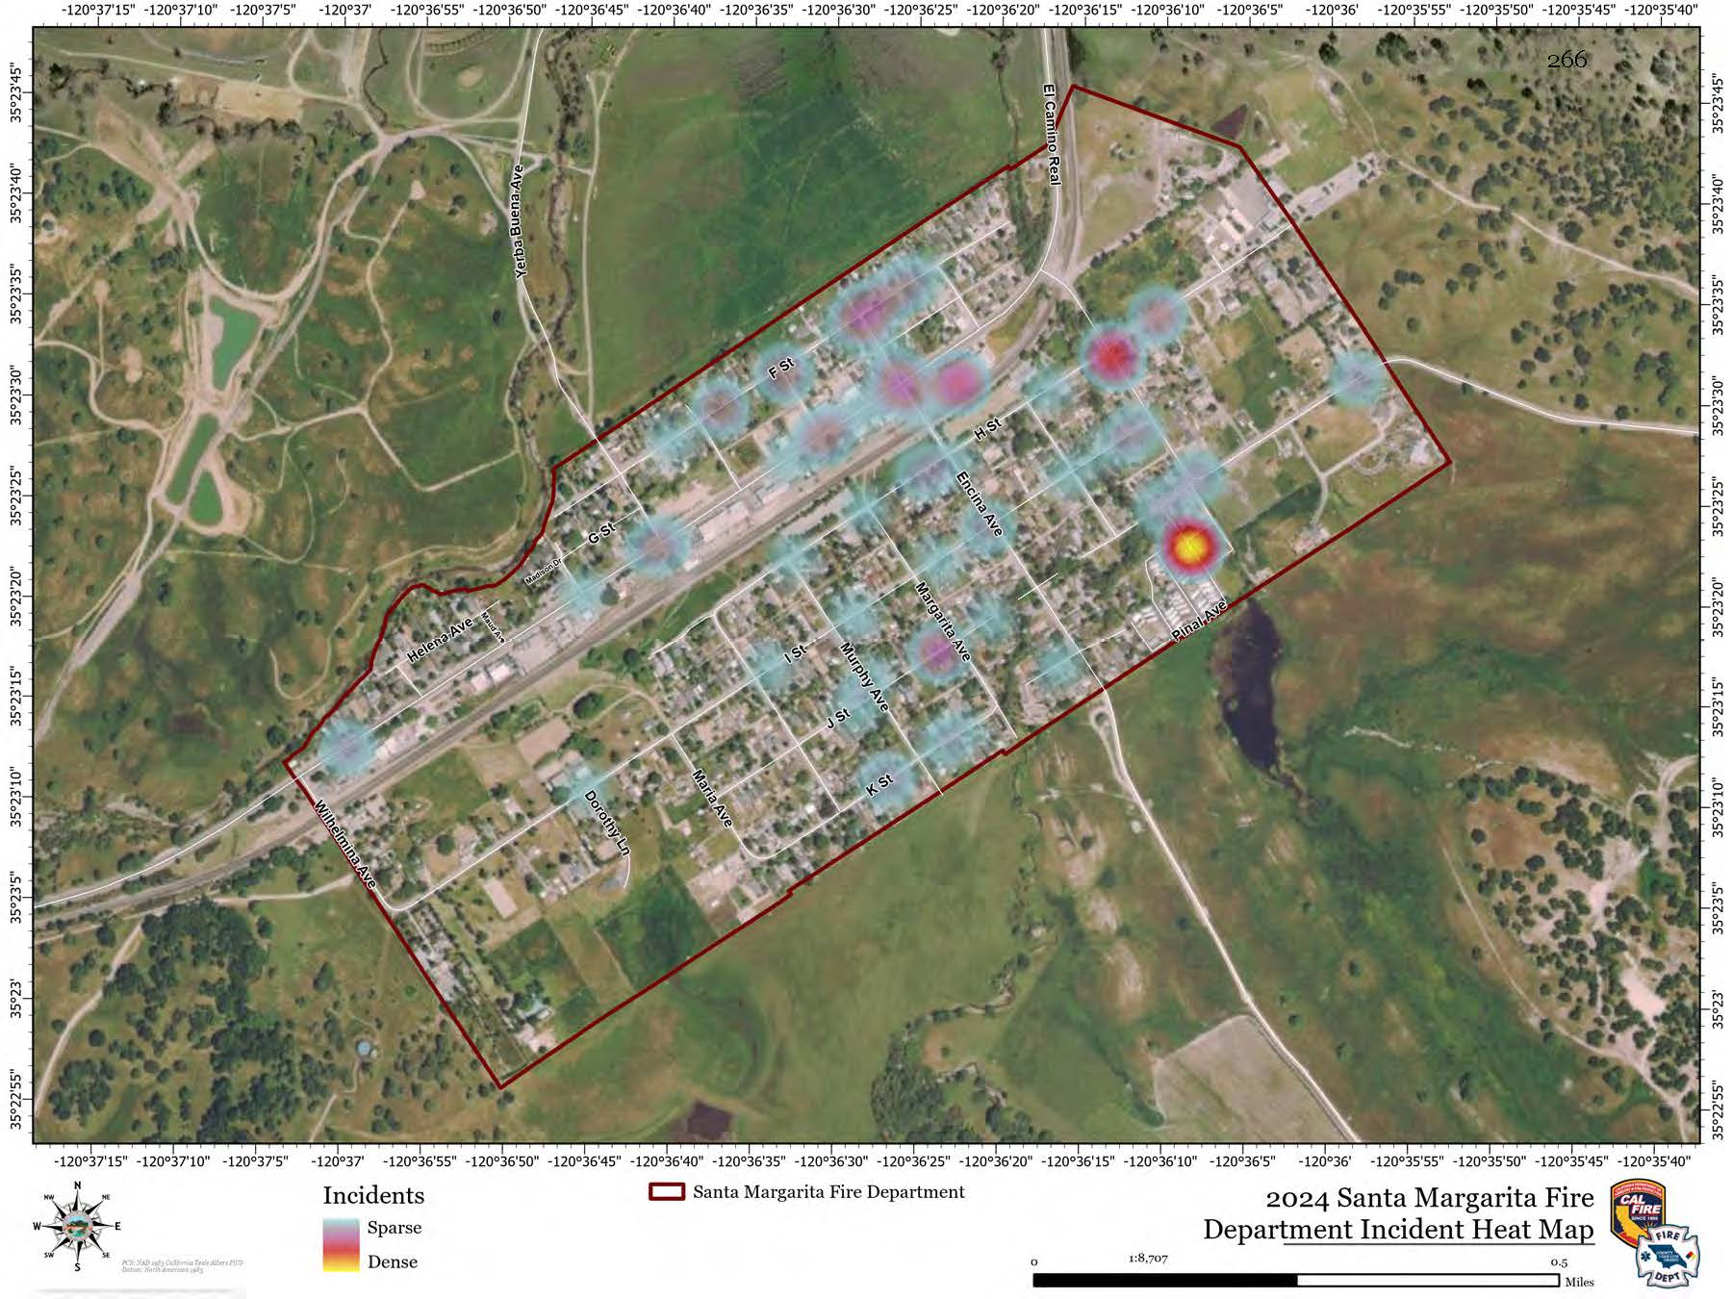
The map in Figure 9, prepared by County Fire, represents the response times from only the SMFPD Station on El Camino Real. The County Fire Strategic Plan Level of Service Analysis recommends a minimum of a “Suburban Service Level” for Santa Margarita, which equates to an eight-minute response time for 90% of the District. With prompt turnout from on-call PCF firefighters, the SMFPD can cover 100% of the District in a seven-minute response time. The shaded green area represents a drive time of up to seven minutes, the blue shaded area represents a drive time of over seven minutes and under eight minutes, while the yellow shaded area represents a drive time of eight minutes to fifteen minutes. In all cases, three minutes are added for “reflex” time, which includes the time required to dispatch the call, assemble the crew, don the appropriate gear for the response, and get out the door. Reflex times for an all PCF operation can vary widely depending on the availability and location of the firefighter when the response is initiated.
Figure 9: SMFPD Response Times
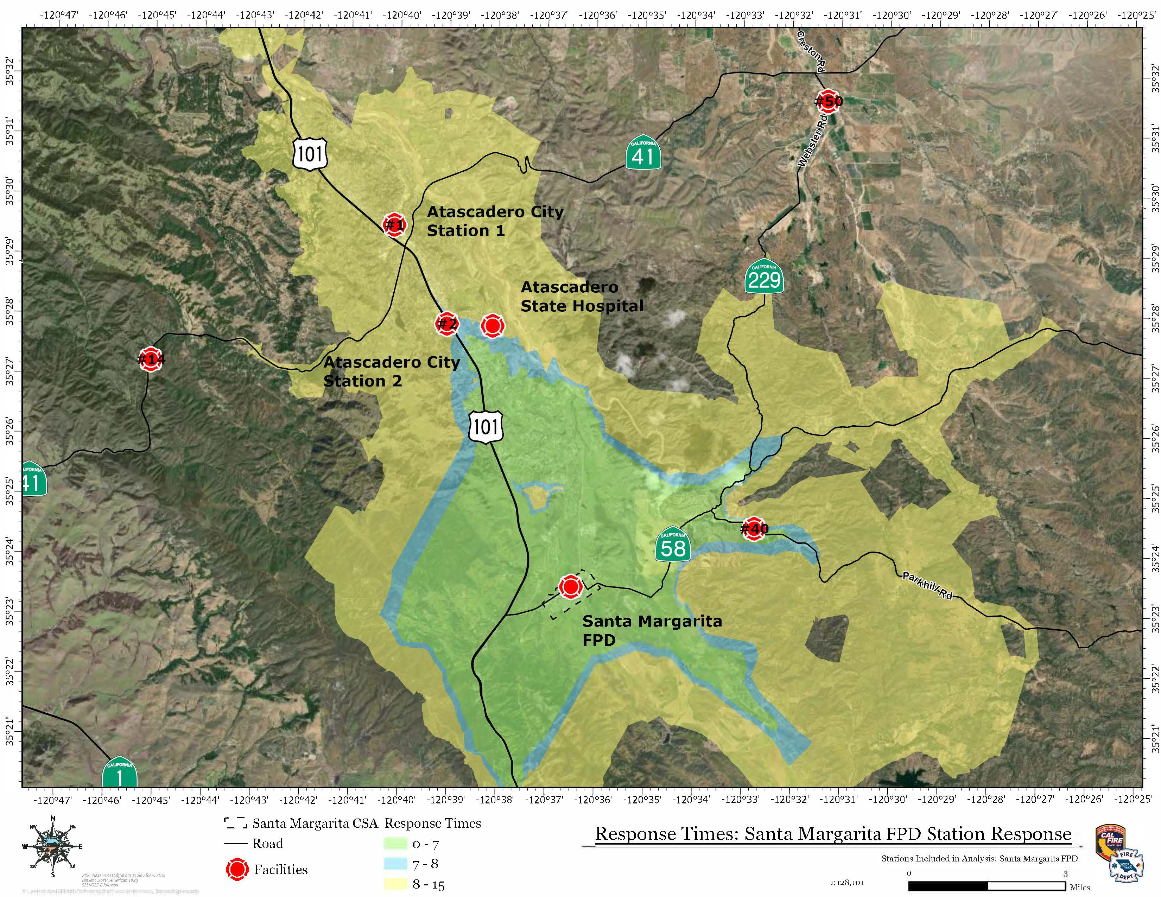
The following map, prepared by County Fire, uses the same values as the map in Figure 9; however, this map removes SMFPD Station from the analysis and considers automatic and mutual aid response times from nearby fire stations. SMFPD has no close fire agency neighbors; however, Automatic aid is provided by Cal Fire/County Fire Station 40 (Parkhill Road), which is 5 miles east on Highway 58. The next closest mutual aid fire stations are the City of Atascadero and the Atascadero State Hospital, which are both 7 miles north of the District. The closest ambulance responds from Atascadero, approximately 14 minutes away. The automatic or mutual aid stations can provide a response to the District in a time that meets County standards for a suburban level of service (8 minutes).
Figure 10: Surrounding Station Response Times
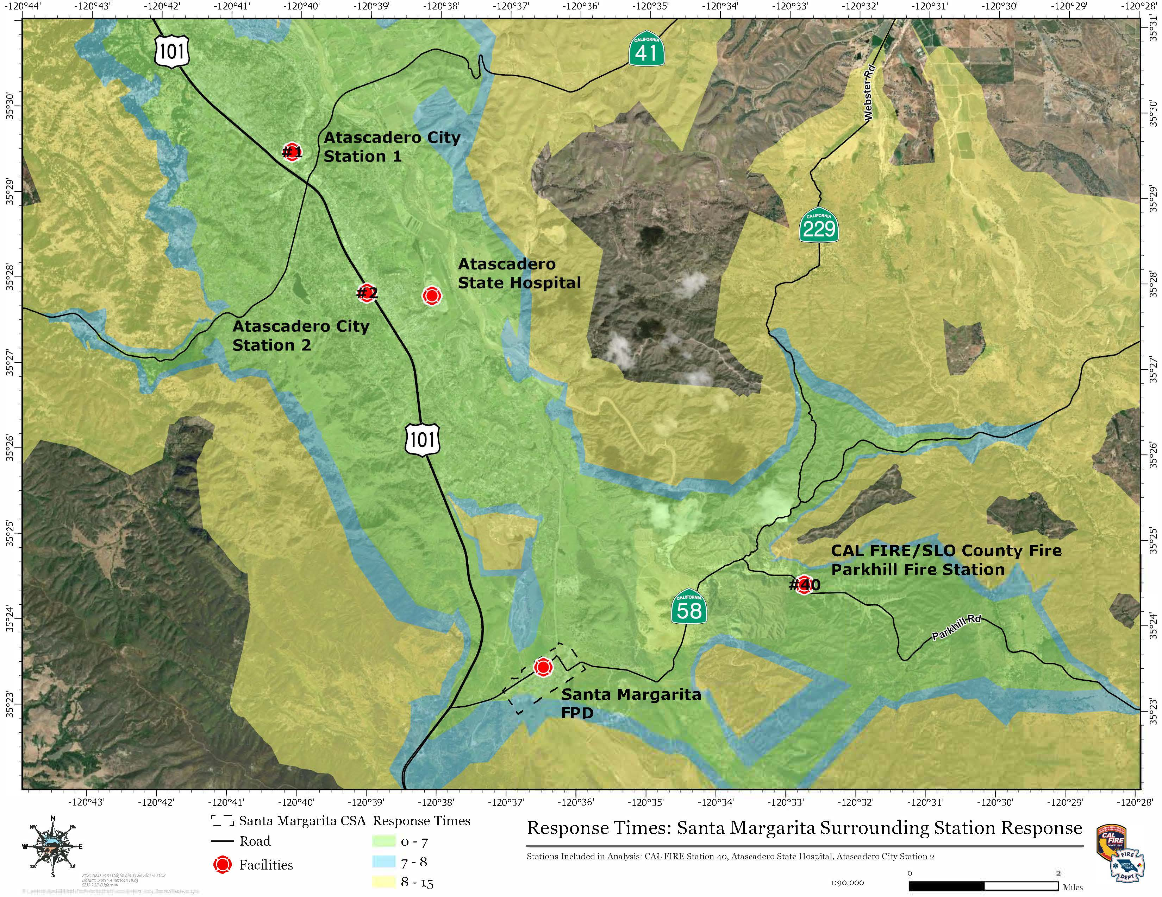
Capital Facilities & Equipment
Fire protection is provided from SMFPD’s fire station at 22375 El Camino Real, which was constructed in 1964. SMFPD’s fire station has flooded several times, and they report that the station is insufficient to support District operations and is in serious need of replacement. The District has purchased a nearby vacant lot on El Camino Real to construct a new fire station and has earmarked $250,000 for construction.
Health and Safety Code 13906 states that the amount of indebtedness a fire protection district can take on cannot exceed an amount equal to three times the actual income from property taxes received for the fiscal year preceding the year in which the indebtedness is incurred. Given the District’s total actual property tax in FY 2023-2024 was $148,084, a maximum debt of $444,252 would be allowed by state law. When added to the reserved amount, the figure is $694,252. While the District is making efforts toward reserving funds for a new facility, the gap between the available funding and the cost of constructing an essential service building is substantial.

The District has been successful in obtaining grants for new equipment and donations of used fire apparatus. SMFPD has two fire engines and a patrol vehicle. Table 7 below further details the District’s apparatus and equipment. Engine 7891 and Patrol 78 are fully paid off, and the District still owes approximately $60,000 on the loan for Engine 7863.
Table 7: SMFPD Apparatus Inventory
Number | Type | Make | Seats
Engine 7891 | Type 1 Engine | Seagrave | 6
Engine 7863 | Type 3 Engine | HME | 5
Patrol 78 | Type 6 Patrol | Ford F-450 | 5

Shared Facilities & Other Matters Related to Efficient Service Delivery
As discussed in previous sections, growth induced by the SMR Subdivision, approved by the County in 2008 but not yet constructed, may directly affect SMFPD’s service capability and capacity. According to the conditions of approval associated with the Conditional Use Permit for the SMR Subdivision, prior to any development on the site, the applicant shall provide for a new County Fire/Cal Fire Station to be located near the project site either through the construction of the station or through the payment of in-lieu fees, as determined in consultation with the County Public Works Department and County Fire/Cal Fire. The County has also identified construction of a new County Fire/Cal Fire station in the Garden Farms/Santa Margarita area as a high-priority project as County Fire Engine 40 located on Parkhill Road (See Figure 10 above) is currently stationed well outside its primary incident response area and is unable to provide the necessary suburban service level to Garden Farms/Santa Margarita from its existing location. On February 25, 2025, the County Board of Supervisors provided direction to County staff to complete a feasibility study and conceptual plan for the relocation of County Fire Engine 40 on Parkhill Road to the community of Santa Margarita, in close proximity to the current SMFPD Fire Station, on El Camino Real. The approximate relocation site is depicted in the following map.
Figure 11: Proposed Relocation Site for County Fire Engine 40
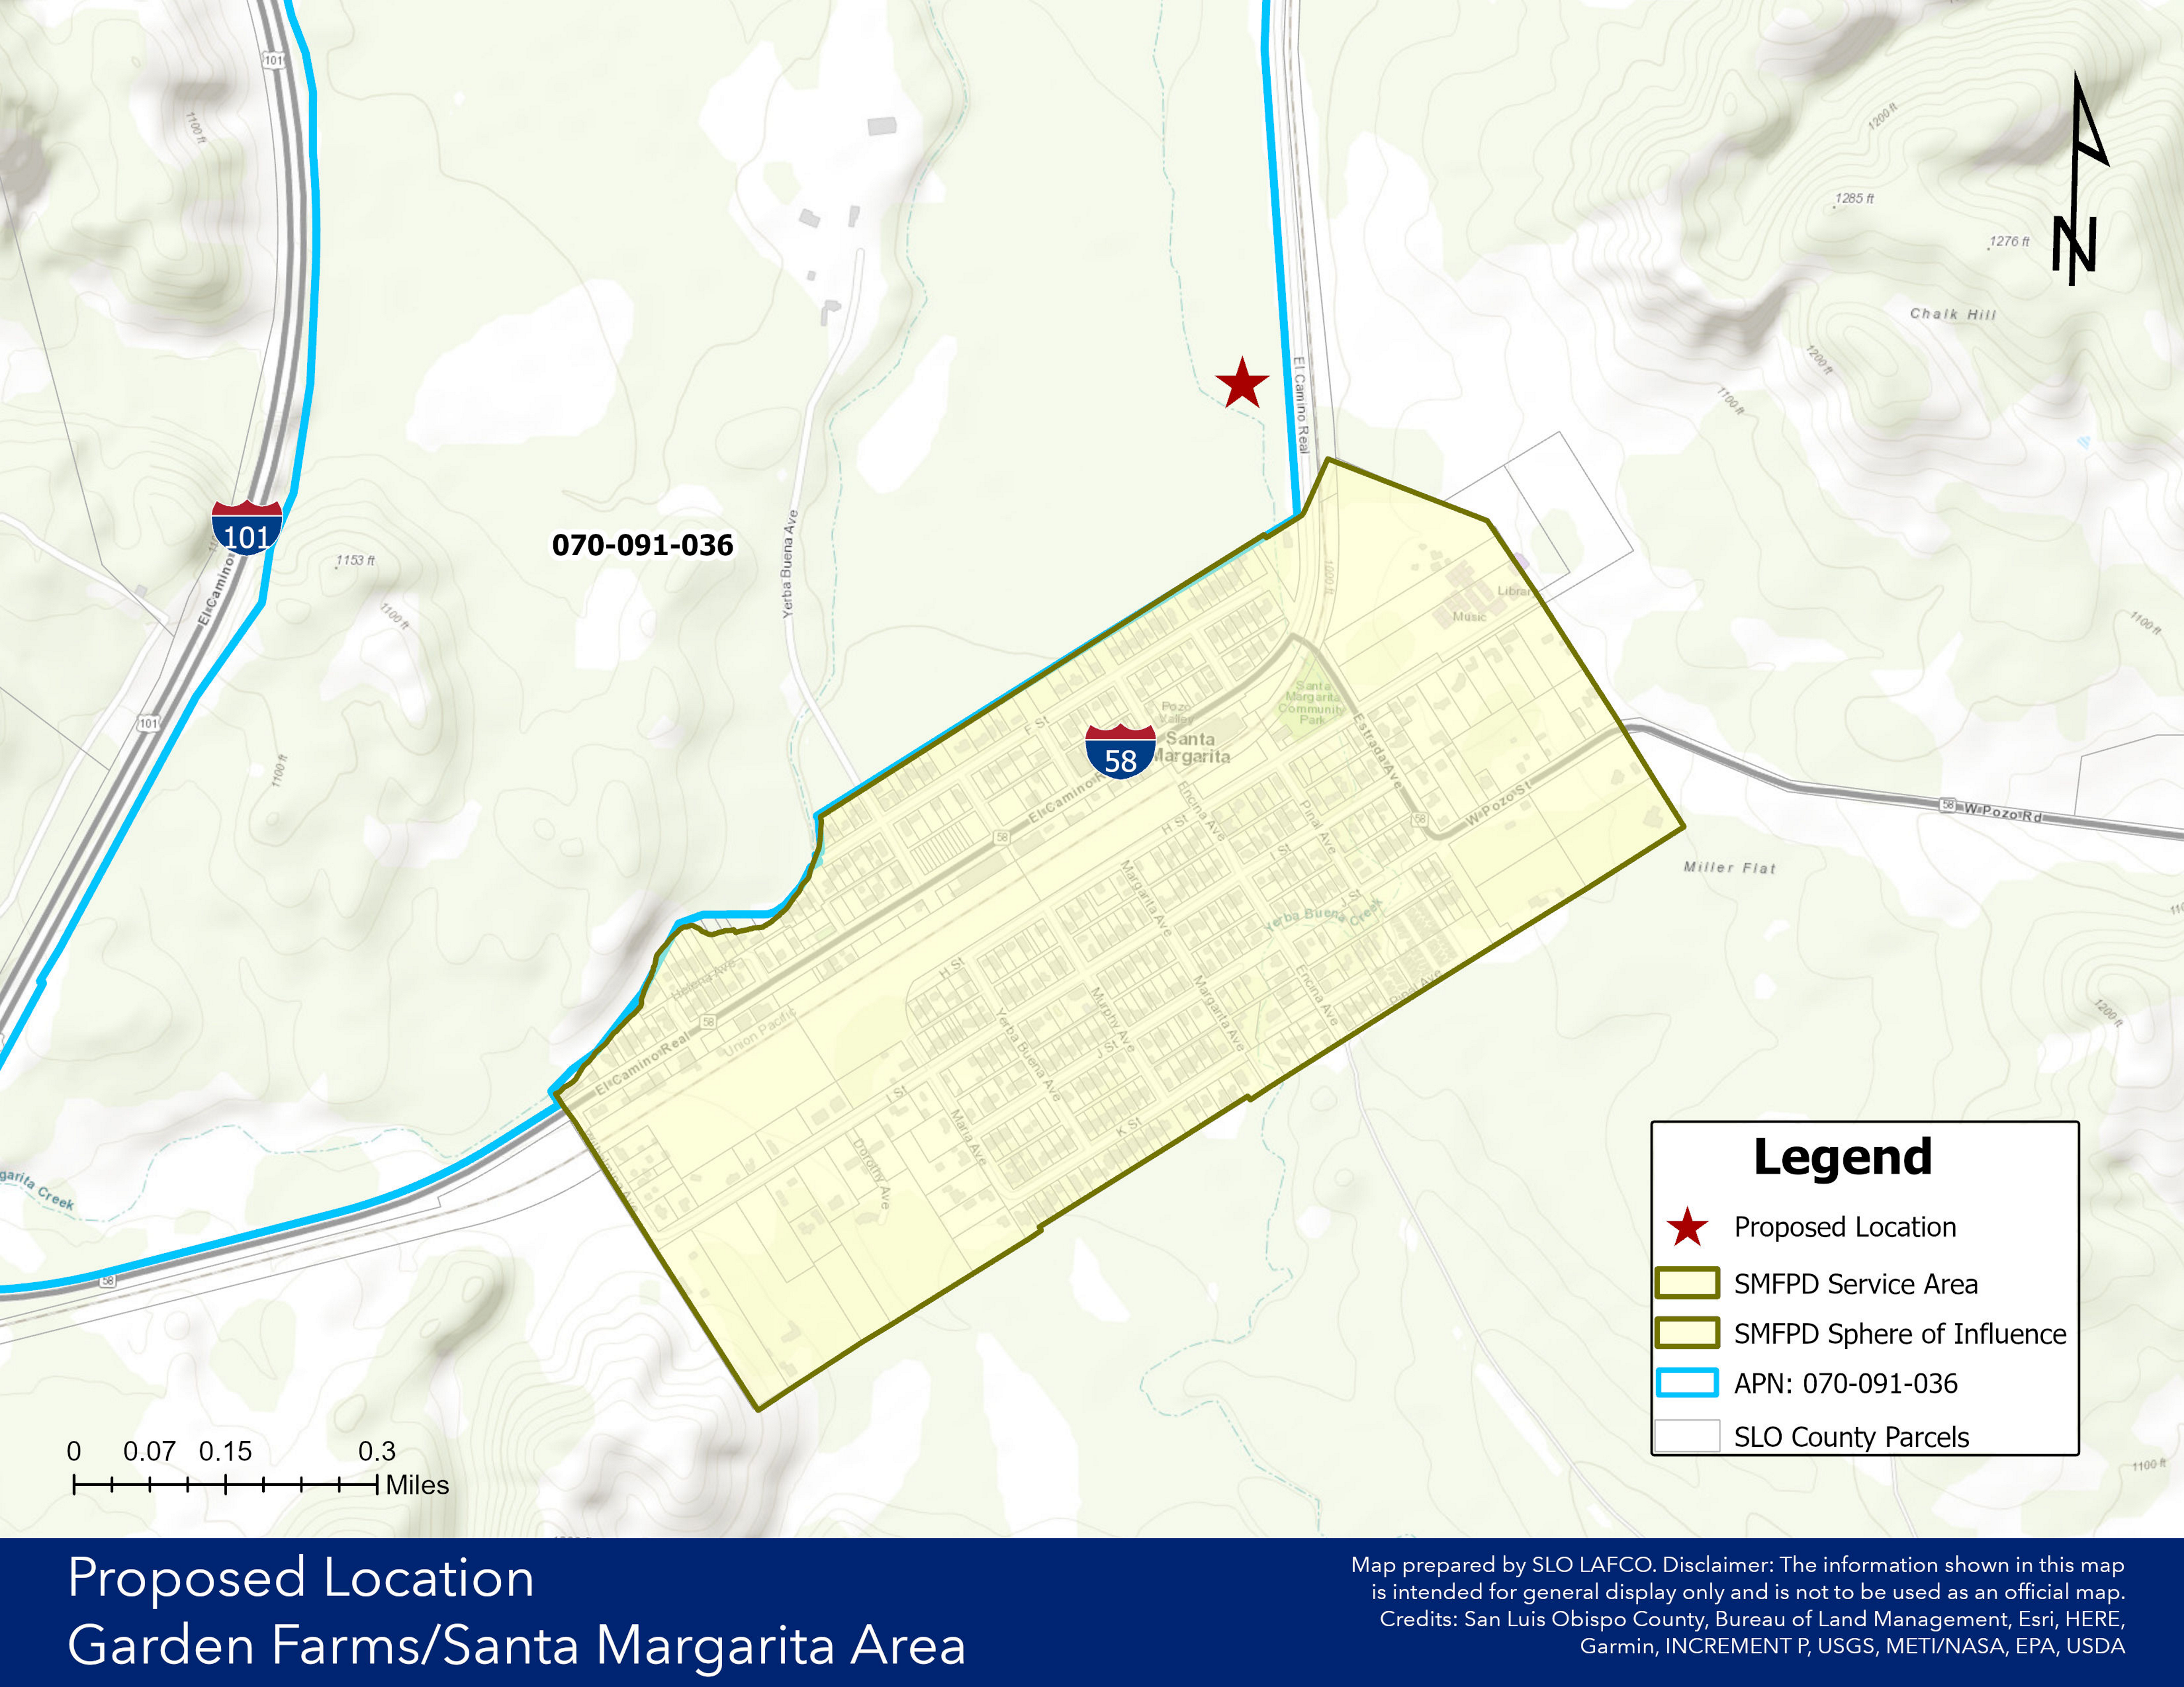
Upon completion of the feasibility study and conceptual plan, land for this project may be donated; however, the timing of construction of the new fire station is unknown at this time. Therefore, the SMR Subdivision may be constructed prior to the construction and operation of the station. LAFCO acknowledges that the timing of construction of the new County Fire/Cal Fire Station in Santa Margarita may result in several service and capacity impacts for SMFPD. The information below describes several considerations that should be made amongst the affected agencies, dependent on the timing of the relocation of County Fire Engine 40 to Santa Margarita.
- Coordinated Capital Planning - SMFPD has a critical need for a new fire station and has begun preliminary steps to construct a new station near the existing SMFPD station; however, funding for a fire station replacement is deficient. The District may choose to postpone construction of a new fire station until the timing of construction of the new County Fire Station in Santa Margarita is known in order to avoid the duplicative expense and effort of building two new fire stations within close proximity to one another. When County Fire Engine 40 is relocated to Santa Margarita, County Fire is expected to provide fire protection with a “Suburban Service Level” or eight-minute response time within the CSA 23 / SMFPD service area boundary. Construction of two new fire stations (County Fire Engine 40 & SMFPD) in close proximity to one another may therefore be unnecessary and may result in an inefficient provision of service and expenditure of tax dollars.
- Joint Fire Station - As part of the feasibility study and conceptual plan, the County may choose to consider a joint fire station shared between County Fire and SMFPD, as best government practices would suggest that a cooperative approach in a joint fire station is more efficient than duplicating expensive construction projects. However, there are existing concerns that two agencies sharing space in a single fire station may not be supported by the respective fire agencies.
- Expansion of SMFPD Service Area Boundary - Should development of the SMR Subdivision occur prior to construction of the new County Fire Station in Santa Margarita, the SMFPD would likely be the first agency to respond to the SMR Subdivision via Automatic Aid Agreements due to their nearby location and no other close fire agency neighbors. In this scenario, the SMFPD could explore annexation of the SMR Subdivision area to receive additional property tax funding. LAFCO does not recommend expansion of SMFPD’s SOI at this time; however, this option should be considered further should the timing of relocation of County Fire Engine 40 be significantly protracted.
- Enhanced County Funding / Support – If expansion of SMFPD’s service area boundary is unsupported or infeasible, the County could consider allocating additional property tax to the District so as to improve the financial stability and service capacity of SMFPD, whether the funding is temporary or long-term. This, in turn, could ease the demand for a new fire station during the interim period noted above or in the long term.
- Dissolution – Should the County move forward with construction of a new County Fire Station upon completion of the feasibility study and conceptual plan, dissolution of the SMFPD could also be a consideration. At this time, dissolution is not recommended as there is an existing need for service within the District and the Community of Santa Margarita, with no nearby fire agency neighbors. Should fire service be found to be duplicative in the future, and dissolution of SMFPD be considered further, the District’s current property tax funding could be transferred to the County through a property tax exchange. The revenue transferred from the District to the County could be utilized toward partial payment for fire station construction and/or equipment replacement.
The analysis above represents the complexities of the situation and how key decisions and the timing of those decisions will affect SMFPD’s service capabilities. At this time, it appears that limited coordination between the County, County Fire, and SMFPD has occurred regarding fire station location and provision of service within the Community of Santa Margarita. As the feasibility study and conceptual plan progress and construction of a new fire station is further examined, increased coordination and communication amongst affected agencies are encouraged to prevent a potentially inefficient provision of fire service.

Determinations

Municipal Service Review Determinations
As set forth in Government Code Section 56430(a), in order to prepare and to update the SOI in accordance with Government Code Section 56425, the Commission shall conduct a service review of the municipal services provided in the County or other appropriate area designated by the Commission. The Commission shall include in the area designated for a service review the county, the region, the sub-region, or any other geographic area as is appropriate for an analysis of the service or services to be reviewed, and shall prepare a written statement of its determinations with respect to each of the following:
- Growth and population projections for the affected area
In 2020, the total estimated population within SMFPD was 1,291. At buildout, the population is expected to be approximately 1,466, with an estimated buildout year of 2050. Although limited population growth is expected within the current SMFPD boundary, growth induced by the nearby SMR Subdivision is expected to generate approximately 300 additional residents by 2032-2034. This represents an approximate 23.2% increase in the existing population of the Santa Margarita community, potentially resulting in service and capacity challenges for SMFPD.

The County plans to conduct a feasibility study and conceptual plan for the relocation of County Fire Engine 40 to the community of Santa Margarita, which, once constructed, would service the SMR Subdivision. Due to its isolated location with no close fire agency neighbors, should the SMR Subdivision be developed prior to relocation of County Fire Engine 40, the SMFPD would likely be the first agency to respond through Automatic Aid Agreements. As the feasibility study and conceptual plan progresses and construction of a new County Fire Station in Santa Margarita is further examined, increased coordination and communication amongst affected agencies are encouraged to prevent a potentially inefficient provision of fire service.
- The location and characteristics of any disadvantaged unincorporated communities within or contiguous to the sphere of influence
SMFPD's SOI and service area boundary includes one area that meets the criteria for a DUC as defined by Government Code Section 56033.5. Referred to as Santa Margarita DUC Area #1, the DUC, which encompasses the entirety of the community of Santa Margarita and neighboring rural areas, has an estimated median household income (MHI) of $50,625, which is less than 80 percent of the statewide MHI, and contains approximately 1,189 registered voters. It should be noted that the SMFPD SOI and service area boundary is surrounded by a single property owner (the Santa Margarita Ranch), and the identified DUC includes some agriculture-zoned areas with no registered voters. Should the District seek to evaluate the surrounding area for annexation in the future, disadvantaged communities should be considered further.

- Present and planned capacity of public facilities and adequacy of public services, including infrastructure needs or deficiencies
SMFPD is a single-purpose agency authorized to provide services under Public Health and Safety Code Section 13800. SMFPD is dependent on Paid Called Firefighters (PCF) and has had success in the recruitment and retention of volunteers to date. Given the total of 16 active volunteers, the District should be able to achieve two to three volunteers per call. If PCF recruitment is unsustainable in the future, and there is a need to provide full-time career staff, SMFPD will need to seek additional revenue, most likely through a benefit assessment.
In 2024, the District responded to a total of 200 incidents. With prompt turnout from on-call PCF firefighters, the SMFPD can cover 100% of the District in a seven-minute response time, which meets the "Suburban Service Level" response standard set by the County. SMFPD has no close fire agency neighbors, with Automatic Aid provided by County Fire Engine 40 on Parkhill Road, the City of Atascadero, and the Atascadero State Hospital.
Fire protection is provided from SMFPD’s fire station at 22375 El Camino Real, which was
constructed in 1964. SMFPD’s fire station has flooded several times, and they report that the
station is insufficient to support District operations and is in serious need of replacement to
meet current standards. The District has purchased a vacant lot on El Camino Real to construct
a new fire station; however, funding for construction is insufficient. The District has been
successful in obtaining grants for new equipment and donations of used fire apparatus and
currently has three apparatus in its fleet.
The County plans to conduct a feasibility study and conceptual plan for the relocation of County Fire Engine 40 to the community of Santa Margarita. Construction of two new fire stations (County Fire Engine 40 & SMFPD) in close proximity to one another may be unnecessary and may result in an inefficient provision of service and expenditure of tax dollars. As the feasibility study and conceptual plan progress and construction of a new County Fire Station in Santa Margarita is further examined, increased coordination and communication amongst affected agencies are encouraged to prevent a potentially inefficient provision of fire service.

- Financial ability of agencies to provide services
The District Board of Directors adopts an annual budget on a basis consistent with generally accepted accounting principles. The District is primarily funded through property taxes; however, with low comparative assessed value and a small number of parcels, there has been a slow growth of revenue and limited opportunity for revenue generation through benefit assessment. SMFPD's operating ratio, liquidity ratio, and net position were used to analyze the District's financial health. SMFPD's operating ratio, which measures the ratio of annual operating revenues to annual operating expenses, indicated a healthy financial position in four of the last five years audited. The District's liquidity ratio, which measures current assets against current obligations, indicated a healthy financial position across all five audited years. The District's net position, which is the difference between the agency's assets and liabilities, has increased 10.87% over the last five-year audited period, indicating a positive financial trend in the District's financial health.
Overall, the financial indicators used do indicate financial health; however, SMFPD’s current revenues and financial position are not sufficient to fund a staffed fire station, operational costs, or to fund a fire station replacement. Although the District has been successful in acquiring grant funding to date, with rising costs, needed capital projects, and a potentially unsustainable staffing model, the District is in a vulnerable financial position. As the County’s feasibility study and conceptual plan for relocation of County Engine 40 to Santa Margarita progresses, increased coordination and communication amongst affected agencies are encouraged to prevent a potentially inefficient and expensive provision of fire service.

- Status of and opportunities for shared facilities
SMFPD works closely and cooperatively with neighboring fire agencies and maintains automatic and mutual aid agreements to ensure adequate coverage and response times. In addition, County Fire provides dispatch services to the District. The County plans to conduct a feasibility study for the relocation of County Fire Engine 40 to the community of Santa Margarita. As the feasibility study and conceptual plan progress and construction of a new County Fire Station in Santa Margarita is further examined, increased coordination and communication, and discussions regarding shared facilities amongst affected agencies are encouraged to prevent a potentially inefficient provision of fire service.

- Accountability for community service needs, including governmental structure and operational efficiencies
SMFPD is governed by a three-member Board of Directors, who are appointed to four-year terms. District elections have largely gone uncontested for the last several election cycles. Regularly scheduled monthly Board meetings are held and are open to the public. The District’s agendas, board packets, minutes, and financial reports are posted on the fire station window and made publicly available upon request. To maintain compliance with Senate Bill 929, the Brown Act, and increase transparency to the community, the District is encouraged to maintain an up-to-date website and annually update an SB 272 Enterprise System Catalog.

- Any other matter related to effective or efficient service delivery
According to the conditions of approval associated with the SMR Subdivision, the applicant shall provide for a new County Fire Station located near the project site. The County Board of Supervisors has provided direction to County staff to complete a feasibility study and conceptual plan for the relocation of County Fire Engine 40 on Parkhill Road to the community of Santa Margarita, in close proximity to the current SMFPD Fire Station, on El Camino Real, however timing of construction is unknown at this time and the SMR Subdivision may be built prior to construction of the new County Fire Station. Construction of the new County Fire Station may result in significant service and capacity impacts for SMFPD. As the feasibility study and conceptual plan progress and construction of a new County Fire Station in Santa Margarita is further examined, increased coordination and communication amongst affected agencies are encouraged to prevent a potentially inefficient provision of fire service.

Sphere of Influence Determinations
In order to carry out its purposes and responsibilities for planning and shaping the logical and orderly development of local governmental agencies to advantageously provide for the present and future needs of the county and its communities, the Commission shall develop and determine the Sphere of Influence of each local agency, as defined by Government Code Section 56036, and enact policies designed to promote the logical and orderly development of areas within the sphere. In determining the Sphere of Influence of each local agency, the Commission shall consider and prepare a written statement of its determinations with respect to the following:
- Present and planned land uses in the area, including agricultural and open-space lands.
Land uses within the SMFPD’s coterminous SOI and service area boundaries are subject to the Santa Margarita Community Plan. The community of Santa Margarita is close to being built out in its residential areas. Although it has enough land designated for a 100 percent increase in commercial development, commercial development is expected to be slow. The primary land use designations within the District are Residential Suburban and Residential Single Family. The District does not contain any land within the Agriculture or Open Space land use categories; however, outside the District boundary, the nearby SMR Subdivision, which consists of 111 residential lots, is within the Agriculture land use category. The County plans to conduct a feasibility study and conceptual plan for the relocation of County Fire Engine 40 to the community of Santa Margarita, which may result in service and capacity impacts for SMFPD. No modifications to SMFPD’s SOI are recommended at this time, however upon completion of the County’s feasibility study and conceptual plan for the relocation of County Fire Engine 40 to Santa Margarita, LAFCO shall conduct another MSR and SOI study for the District, and the SOI and service area boundaries should be reconsidered at that time.

- Present and probable need for public facilities and services in the area.
There is a present and probable need for fire protection services in the area as the Community of Santa Margarita is in an isolated location with no close County Fire station or other nearby fire agency neighbors. Automatic aid is provided by County Fire Station 40 on Parkhill Road, 5 miles east on Highway 58. The next closest mutual aid fire stations are the City of Atascadero and Atascadero State Hospital, which are both 7 miles north. The closest ambulance responds from Atascadero, approximately 14 minutes away.
The County plans to conduct a feasibility study and conceptual plan for the relocation of County Fire Engine 40 to the community of Santa Margarita, which may result in service and capacity impacts for SMFPD. No modifications to SMFPD’s SOI are recommended at this time, however upon completion of the County’s feasibility study and conceptual plan for the relocation of County Fire Engine 40 to Santa Margarita, LAFCO shall conduct another MSR and SOI study for the District, and the SOI and service area boundaries should be reconsidered at that time.
- Present capacity of public facilities and adequacy of public services that the agency provides or is authorized to provide.
SMFPD is a single-purpose agency authorized to provide services under Public Health and Safety Code Section 13800. SMFPD is dependent on Paid Called Firefighters (PCF) and has had success in the recruitment and retention of volunteers to date. Given the total of 16 active volunteers, the District should be able to achieve two to three volunteers per call. If PCF recruitment is unsustainable in the future, and there is a need to provide full-time career staff, SMFPD will need to seek additional revenue, most likely through a benefit assessment.
In 2024, the District responded to a total of 200 incidents. With prompt turnout from on-call PCF firefighters, the SMFPD can cover 100% of the District in a seven-minute response time, which meets the "Suburban Service Level" response set by the County. SMFPD has no close fire agency neighbors, with Automatic Aid provided by County Fire Engine 40, the City of Atascadero, and the Atascadero State Hospital.
Fire protection is provided from SMFPD’s fire station at 22375 El Camino Real, which was
constructed in 1964. SMFPD’s fire station has flooded several times, and they report that the
station is inadequate to support District operations and is in serious need of replacement. The
District has purchased a vacant lot on El Camino Real to construct a new fire station; however,
funding for construction is insufficient. The District has been successful in obtaining grants for
new equipment and donations of used fire apparatus and currently has three apparatus in its fleet.
The County plans to conduct a feasibility study and conceptual plan for the relocation of County Fire Engine 40 to the community of Santa Margarita, which may result in service and capacity impacts for SMFPD. No modifications to SMFPD’s SOI are recommended at this time, however upon completion of the County’s feasibility study and conceptual plan for the relocation of County Fire Engine 40 to Santa Margarita, LAFCO shall conduct another MSR and SOI study for the District, and the SOI and service area boundaries should be reconsidered at that time.
- Existence of any social or economic communities of interest in the area if the commission determines that they are relevant to the agency.
There are no social or economic communities of interest within the District service area boundary.
- For an update of the sphere of influence of a city or special district that provides public facilities or services related to sewers, municipal and industrial water, or structural fire protection, the present and probable need for those public facilities and services of any disadvantaged unincorporated communities within the existing sphere.
SMFPD's coterminous SOI and service area boundary includes one area that meets the criteria for a DUC as defined by Government Code Section 56033.5. Referred to as Santa Margarita DUC Area #1, the DUC, which encompasses the entirety of the community of Santa Margarita and neighboring rural areas, has an estimated median household income (MHI) of $50,625, which is less than 80 percent of the statewide MHI, and contains approximately 1,189 registered voters. It should be noted that the SMFPD SOI and service area boundary is surrounded by a single property owner (the Santa Margarita Ranch), and the identified DUC includes some agriculture-zoned areas with no registered voters. No modifications to SMFPD’s SOI are recommended at this time, however upon completion of the County’s feasibility study and conceptual plan for the relocation of County Fire Engine 40 to Santa Margarita, LAFCO shall conduct another MSR and SOI study for the District, and the SOI and service area boundaries should be reconsidered at that time.

SLOCOG, 2050 Regional Growth Forecast for San Luis Obispo County, June 2017
Final Environmental Impact Report for the Santa Margarita Ranch Agricultural Residential Cluster Project and Future Development Program, State Clearinghouse Number 2004111112
2024 CAL FIRE/San Luis Obispo County Fire Department ECC Workload Summary
Map produced and provided by CAL FIRE/San Luis Obispo County Fire Department
Map produced and provided by CAL FIRE/San Luis Obispo County Fire Department

